**Dental Clinic System**

**Abstract**

My project “Dental Clinic System” is a web application from which the users can know the information about the services provided by the dentistry online. This project provides an interface for the users to get register themself and book the appointment for the services done in the dental clinic.

Users can view all the services provided by the clinic in detail from the website within a minute at anywhere using the internet.

The user can easily communicate with the Doctor for asking in detail information about the services provided by them.

This project makes all the services provided by the clinic easier.

**Acknowledgement**

I am really thankful and grateful that I have completed my third year’s project “Dental Clinic System” with the help, support and guidance of our lecturer “Smt. Navneet Kaur Nagpal”.

She helped me throughout the project without any delay and supported me whenever I had a doubt related to project and the documentation process by suggesting new features and ideas that can make my project much better.

I would also like to thank Our Coordinator of BScIT at M.L. Dahanukar College of Commerce “Smt. Archana Talekar” for the support that she provided throughout my graduation.

My project would have never completed with the help of our great lecturer and Coordinator.

**Declaration**

I hereby declare that the project entitled, “Dental Clinic System” done at Mumbai, Maharashtra has not been duplicated in any case. To the best of my knowledge other then me no one has submitted to any other University.

The project is done in partial fulfilment of requirements for the award of degree of BACHELOR OF SCIENCE (INFORMATION TECHNOLOGY) to be submitted as Final Semester Project as the part of our curriculum.

Gupta Jyoti Chandrakant

**Table Of Content**

Page No.

Chapter: 1 Introduction

* 1. Background 8
  2. Objectives 8
  3. Purpose, Scope, Applicability
     1. Purpose 8
     2. Scope 9
     3. Applicability 9
  4. Achievements 10
  5. Organization Of Report 10

Chapter: 2 Survey Of Technology

2.1 Front End 11

2.2 Back End 13

2.3 Survey 15

2.4 Statistics 16

Chapter: 3 Requirement And Analysis

3.1 Problem Definition 21

3.2 Models

3.2.1 Waterfall Model 21

3.3 Conceptual model

3.3.1 Entity Relationship Diagram 23

3.3.2 Sequence Diagram 25

3.3.3 Use Case Diagram 27

3.3.4 Activity Diagram 29

3.3.5 Class Diagram 32

3.3.6 Data Flow Diagram 34

3.3.7 Flowchart 37

3.4 Planning and Scheduling

3.4.1 Gannt Chart 39

3.4.2 Pert Chart 40

3.5 Software and Hardware

3.5.1 Software 42

Chapter: 4 System Designing

4.1 Pseudo Code 43

4.2 Software Testing 44

4.3 Design 44

Chapter: 5 Implementation and Testing

5.1 Model

5.1.1 Waterfall Model 57

5.2 Coding 58

5.3 Testing

5.3.1 Unit Testing 66

5.3.2 Whitebox Testing 64

5.3.3 Error Handling Testing 64

5.3.4 Graphical User Interface Testing 65

5.3.5 System Testing 66

5.4 Test Cases 67

5.5 Modifications and Improvements 70

Chapter: 6 Results and Discussion

6.1 Test Reports 71

6.2 User Documentation 74

6.3 Database Design/Tables 78

Chapter 7: Conclusion

7.1 Conclusion 80

7.2 Limitation 80

7.3 Future Scope 80

**List Of Tables**

|  |  |  |
| --- | --- | --- |
| **Table Number** | **Contents** | **Page Number** |
| 5.4 | Test Cases | 67 |
| 6.1 | Test Reports | 70 |

**List Of Figures**

|  |  |  |
| --- | --- | --- |
| **Figure Number** | **Contents** | **Page Number** |
| 3.3.1 | Entity Relationship Diagram | 23 |
| 3.3.2 | Sequence Diagram | 25 |
| 3.3.3 | Use Case | 27 |
| 3.3.4 | Activity Diagram | 29 |
| 3.3.5 | Class Diagram | 32 |
| 3.3.6 | Data Flow Diagram | 34 |
| 3.3.7 | Flow Chart | 37 |

**CHAPTER:1 INTRODUCTION.**

* 1. **Background:**

Presently the clinic functionalities are done manually. That is, if the patient wants to consult a Doctor he/she can visit there till his chance called.

An appointments are distributed directly.

The work in the clinic is done manually, paper works and registers are maintained for the patients.

The main disadvantage is time consuming.

Limitation of existing system is, if patient loses their receipt, difficulties to find out the patient token assign.

To defect this limitations we do computer based web application.

**1.2 Objectives:**

The aim of this system is to improve the management of the dental clinic and reduce the human efforts.

The main objective of the project on Dental Clinic System is to manage the details of Dental Clinic, Doctor, Patients, Tests, Appointments.

The objective of this system is to ensure the workflow in the clinic will be more systematic and organize.

It tracks all the details about the patient, Tests and Appointments.

**1.3 Purpose, Scope and Applicability:**

**1.3.1 Purpose:**

Our purpose at creating this application is that it will automate the process in Dental Clinic.

Using this it is possible to keep the track of a database for clinic like information about the patient and appointment schedule, personal records, previous medical records, treatment records, prescription, case reports.

This project is being created for collecting, managing, saving, and retrieval of medical information for the patients, and for creating reports for the patients.

* + 1. **Scope:**

The scope of this project is patient and dentist/consultant management system of dental clinic and has to fulfill all their needs such as registering the patients and capturing their data.

It may help in collecting perfect management details. In a very short period of time, the collection will be obvious, simple and sensible.

It also helps in all current works related to Dental Clinic System.

The level of accuracy in the proposed system will be higher. All the operation would be done correctly and it ensures that whatever information coming from the center is accurate.

It will reduce the redundancy like no information is repeated in the storage. This would assure the economic use of storage space and consistency in the data stored.

The retrieval of any type of information would be available whenever it is required.

It will also reduce the cost of collecting the management and the collection procedure will go on smoothly.

* + 1. **Applicability:**

Dental Clinic System is an automated system designed and developed precisely for the smooth and efficient conduct of the procedure followed in [**Dental Clinics**](https://en.wikipedia.org/wiki/Dental_care).

It is provisioned with logins for user under profile as a patient for the Registration.

The application can be made accessible to the outside world on the internet through the website.

Appointment booking and payment gateway can be enabled directly to the patients with necessary notifications to the employees involved, along with the doctor.

This system can used by the Doctors in their Dental Clinic.

* 1. **Achievements:**

The goals in “Dental Clinic System” is partially achieved as per the specified gaols due to time constraint.

**1.5 Organization of Report:**

Chapter 2 tells us about the different types of technologies and also the survey was conducted for the project.

Chapter 3 tells us about the different types of models and conceptual models and the requirements of software and hardware. I will be using the software Visual Studio (2015) and MySQL Server for my project.

The conceptual models like ER diagram, Activity diagram, DFD, Use Case and Flowcharts.

Further, Chapter 4 tells about the execution of the design of web application.

In Chapter 5 the implementation of project and the description about the Testing Approaches. In Chapter 6 we have Result and Discussion we have Test Case Reports and the User Documentation.

In Chapter 7 the Conclusion is given with Limitation and Scope of Future of my project.

**CHAPTER:2 SURVEY OF TECHNOLOGIES**

* 1. **Front End:**

The Front End of a software program or website is with which the user interacts.

The Front End is a Graphical Interface with which the user interact.

It is the interface design and the programming that makes the interface function. The front end of a software or [website](https://techterms.com/definition/website) should be intuitive and easy to use.

The following programming languages can be used as a Front End Language to develop “Dental Clinic System”:

1] C++:

C++ is an Object-Oriented Programming Language. This is the most important feature of the C++. C++ is a simple language that is it provides structured approach, rich set of library functions, data types etc. C++ can be the base language for many other programming languages that supports the feature of object-oriented programming.

C++ program can support [unions](https://www.geeksforgeeks.org/union-c/) and [structures](https://www.geeksforgeeks.org/structures-c/) that are a mix of stand-alone and put-together files.

It uses the standard C++ application mentioned as **“.cpp”**.

C++ uses the reserved library word mentioned as “[goto](https://www.geeksforgeeks.org/goto-statement-in-c-cpp/)” that’s the same as Java’s continue, or break commands.

C++ uses multi-paradigm programming. Paradigm is planning and programming. It supports Exception Handling. It uses “cin” and “cout” for printing input and output statements.

2] C#:

C# is a general-purpose, object-oriented programming language developed by Microsoft.

C# enables you to develop different types of application such as Windows Based Application, Console Based Application, Web Based Application.

C# was especially developed for .NET Framework.

Interoperability enables the C# programs to do almost anything that a native C++ application can do.

C# is a scalable and updateable language.

In C#, a very efficient system installed that collects and erases garbage automatically present on the system.

C# language has a rich class of libraries that makes functions easy to be implemented.

3] Java:

Java is an [object-oriented](https://www.javatpoint.com/java-oops-concepts) programming language. Everything in Java is an object.

Java is platform independent because it is different from other languages like [C](https://www.javatpoint.com/c-programming-language-tutorial), [C++](https://www.javatpoint.com/cpp-tutorial), etc. Java syntax is based on C++.

Object-oriented means we organize our software as a combination of different types of objects that incorporates both data and behaviour. Java is a simple programming language since it is easy to learn and easy to understand. Java is a robust programming language since it uses strong memory management. Java uses a multi-threaded environment in which a bigger task can be converted into various threads and run separately. Java is a secured programming language because it doesn't use explicit pointers.

4] VB.Net:

VB.Net or Visual Basic .Net is an object oriented programming language. VB.Net is one of the top programming languages with simple structural syntax for programming the code blocks.

It is a platform-independent programming hence it could be compiled on a various of computer platforms and can be run of different OS.

VB.Net is a part of .NET Framework.

VB.Net follows the concept of a component. VB.Net syntaxes are easy to learn.

I have used Front End as Asp.Net with C#.

* 1. **Back End:**

Back End refers to any part of a software program or website that users do not see.

The backend is the "data access layer”.

Back End development is all about making the apps render server-side.

The back end of a website consists of an application, and a database.

Back End stores and arranges data, and also makes sure everything on the client-side of the website works fine.

The parts developed by backend designers are indirectly accessed by users through a front end applications.

The following programming languages can be used as a Back End Language to develop “Dental Clinic System”:

1] MySQL:

MySQL is a Open-Source Database, which uses Structured Query Language.

MySQL holds the ACID (Atomicity, Consistency, Isolation, Durability) property, and also allows distributed multi-version support.

MySQL can run at high speed and also provide master and slave replication configuration and also provide cluster servers.

MySQL is a Relational Database management System.

MySQL supports powerful mechanisms to ensure the security of the data.

MySQL uses a very fast thread-based memory allocation system.

MySQL is very easy to install, it’s also an easy database to work with.

2] Oracle:

Oracle Database is cross-platform. It can run on various hardware across operating systems including Windows Server, Unix and Linux. Oracle Database allows you to quickly and safely store and retrieve data. Oracle uses the logical data structure to store data.

The memory caching architecture in oracle allows you to scale up a very large database that still can perform at a high speed.

Oracle ensure the integrity of the data in case of system failure.

3] Firebase:

Firebase is categorized as a NoSQL database program, which stores data in JSON-like documents. Firebase allows us to deliver and receive messages in a more reliable way across platforms. Firebase auth has a built-in email/password authentication system. Firebase includes an easy-to-use hosting service for all of your static files.

Firebase Storage provides a simple way to save binary files.

4] MongoDB:

MongoDB is a document database, which means it stores data in JSON like documents. MongoDB is a document-oriented NoSQL database used for high volume data storage. MongoDB is a source-available cross-platform.

I have used MySQL as Back End in my project.

* 1. **Survey:**

1. Have you ever visited dental clinic before?
2. Yes b. No
3. Have you faced any Dental Health Problem?

a. Yes b. No

1. How many times have you visited a Dental Clinic?
2. Once b. Twice c. More than 3 times d. Never
3. What would you prefer if you have any dental problem?
4. Home remedies b. Visiting a Dentist
5. When you book an offline appointment, you have to wait at the dentist office for your turn. What do you feel?
6. It is Time Consuming b. It is not Time Consuming.
7. Have you ever placed an appointment related to dental issue online?
8. Yes b. No
9. Would you like to have a consultation online through chats/calls instead of meeting a doctor in a clinic?

a. Yes b. Maybe c. No

1. What do you think about booking an appointment through a registration form online on a website is time saving?
2. Yes b. Maybe c. No
3. Would you trust on the data/description provided on a particular website?
4. Yes b. Maybe c. No d. Not at all
5. What type of payment method would you use after a Treatment?
6. Internet Banking b. Cash Payment c. E-Wallet

1. Would you believe on the feedbacks of the user on a particular website/system?
2. Yes b. Maybe c. No
   1. **Statistics:**

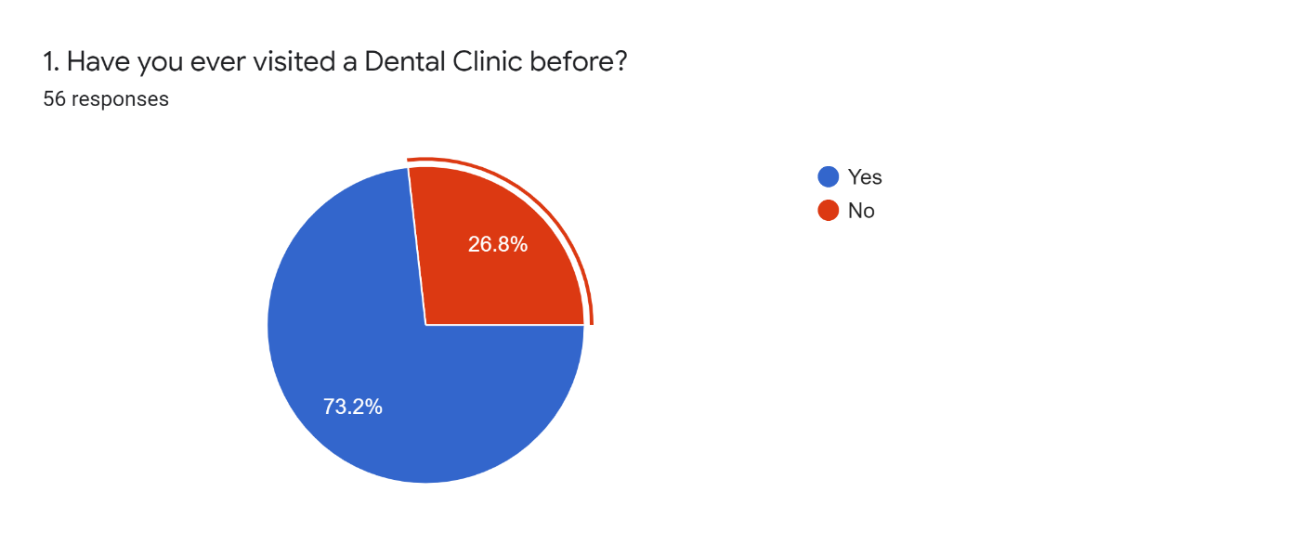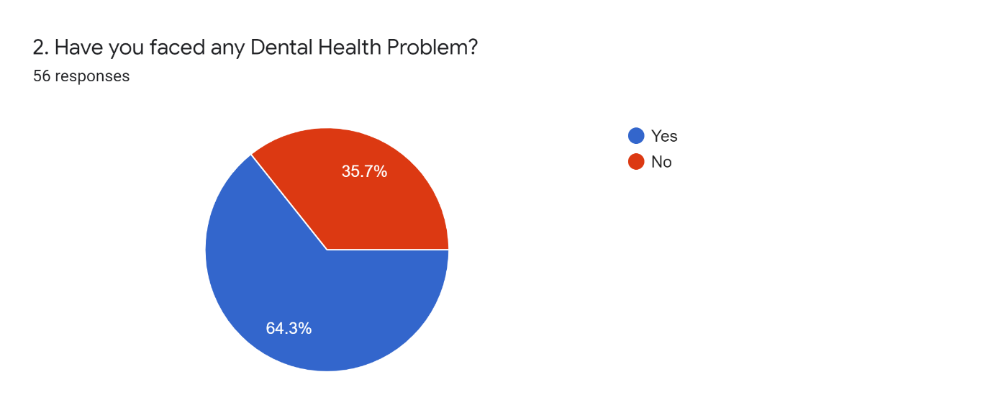

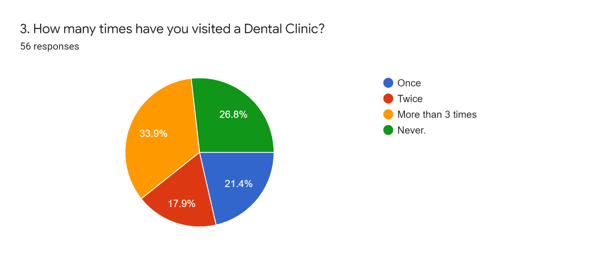

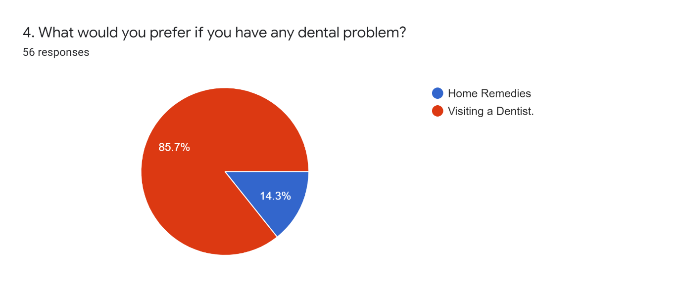

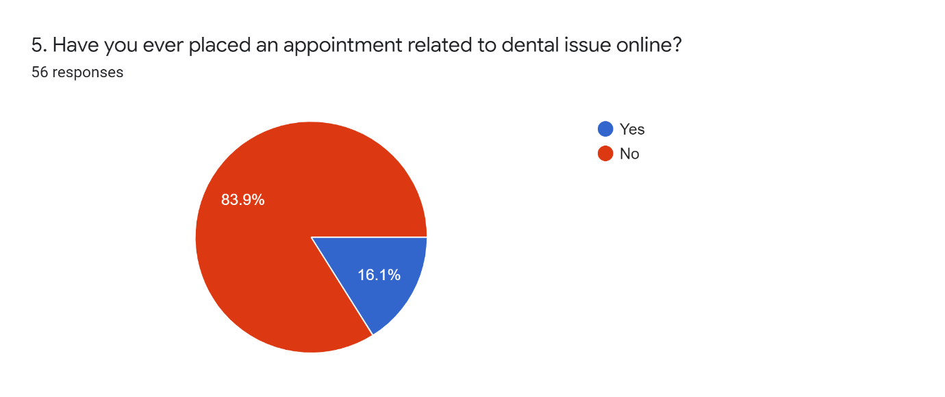

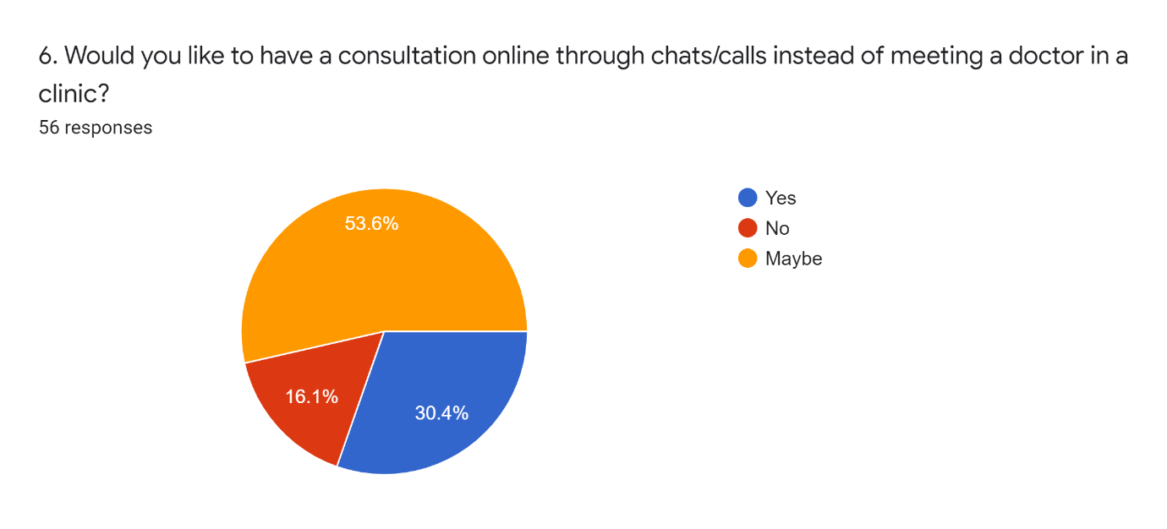

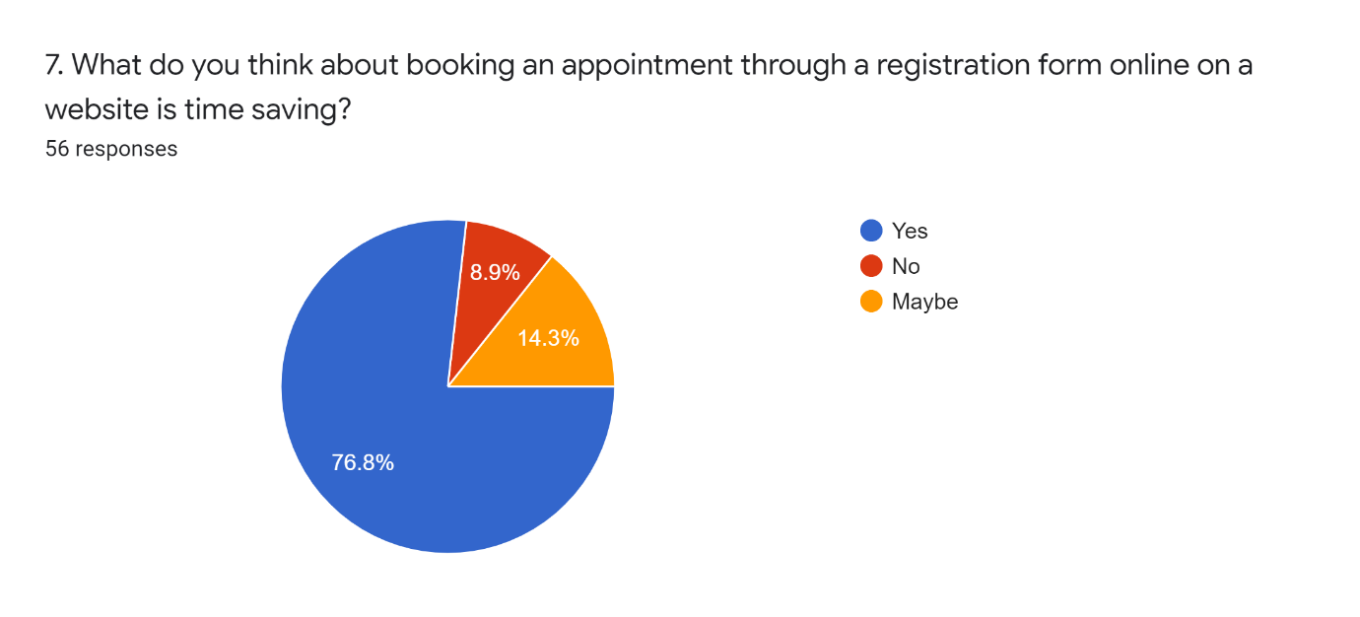

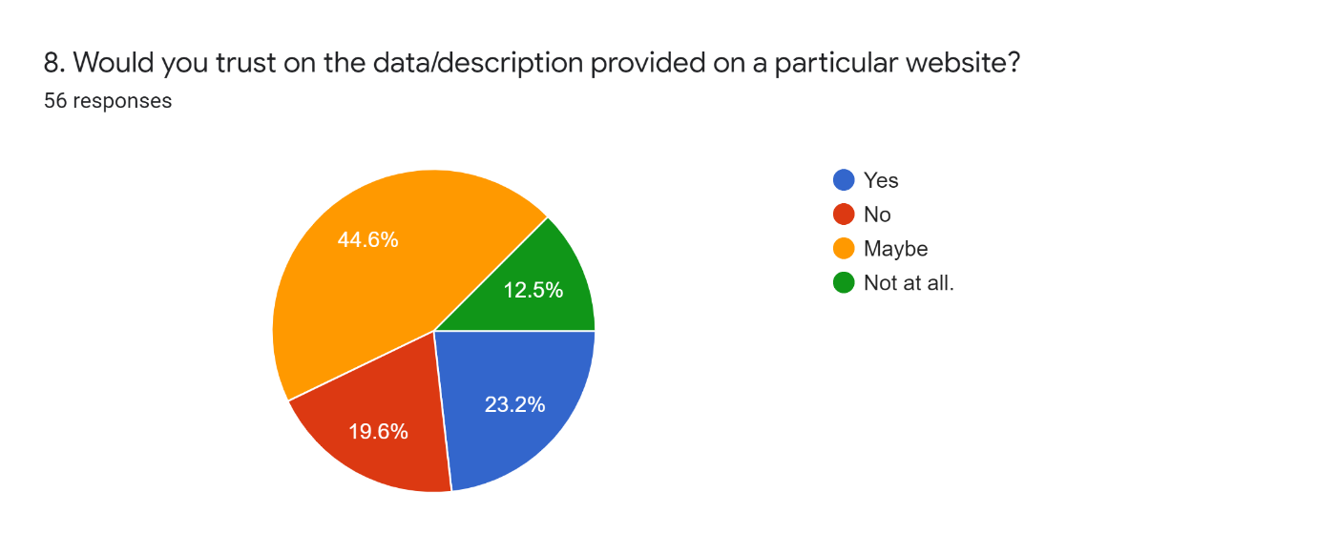 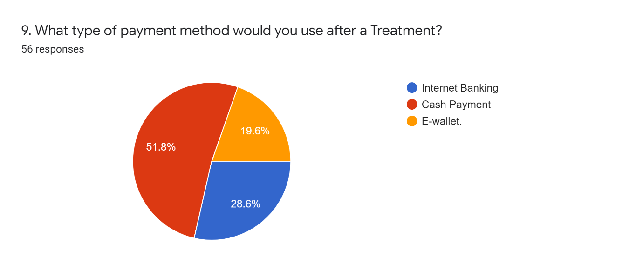

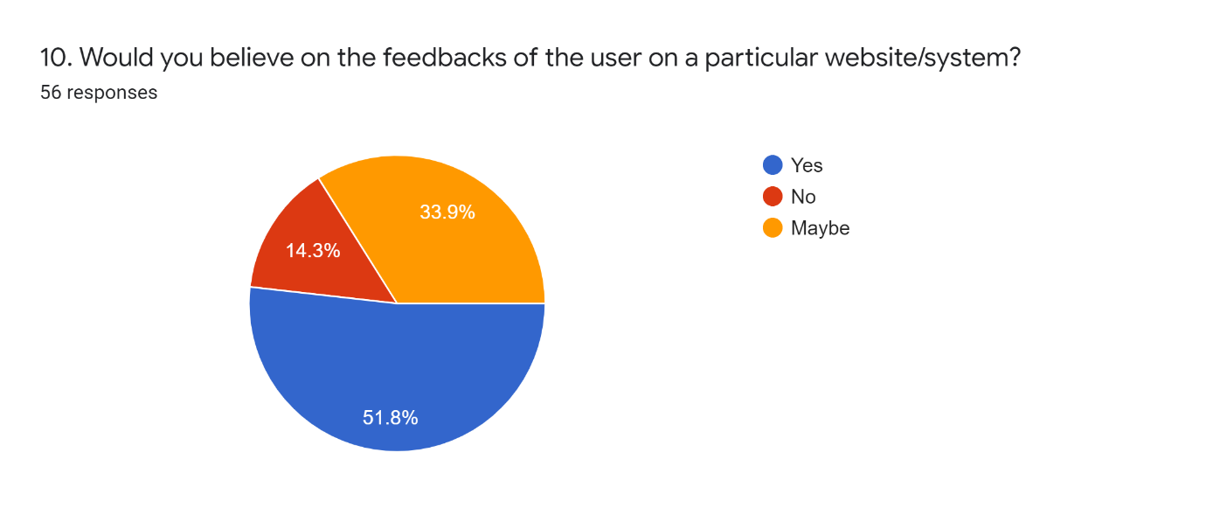

* Result:

1. In the above survey, 56 people have responded the survey in which 73.2% respondents have visited the dental care and 26.8% respondents have never visited any dental clinic before.
2. 64.3% of respondents have faced a dental health problem and around 35.7% respondents never faced any dental health problems.
3. From 100% respondents, 21.4% of respondents have visited dental clinic only once, 17.9% of respondents visited twice and 33.9% more than thrice.
4. In survey it is found that if anyone will suffer from dental problem, 85.7% respondents will visit dentist and 14.3% of respondents will use home remedies.
5. 83.9% of respondents have never placed any appointments online and 16.1 of respondents have placed their appointments online.
6. It is found that 30.4% would like to take consultation of a doctor on call/chats and 53.6% of respondents are not sure about taking a consultation through calls, while 16.3% of respondents would not like to take consultation through calls.
7. 76.8% of respondents thinks that booking an appointment through appointment form is time saving, while 14.3% of respondents are not sure that it is time saving and rest of the respondents thinks that it is not time saving.
8. It is found that 23.2 % of respondents will believe/trust on the data provided on particular website about their service and it is also found that 19.6% of responders won’t trust while 12.5% won’t trust at all and rest are not sure about the data.
9. After visiting the dental clinic and getting done treatment, 51.8% of respondents willing to pay their bill by Cash, and 28.6% are willing to pay their Internet Baking and the remaining respondents are willing pay by E-Wallet.
10. 51.8% of respondents will believe on the feedbacks on a particular website wile 14.3% will not believe and rest of the respondents are not sure to believe or not.

**CHAPTER:3 REQUIREMENT AND ANALYSIS**

**3.1 Problem Definition:**

In this Web-Based Application we can ensure the workflow in the clinic will be more systematic and organize. The user can easily navigate this application and avail the services provided by the Doctor in the Dental Clinic

Using the Visual Studio (2015) I am going to implement the feature of this application.

* 1. **Models:**
     1. **Waterfall Model:**

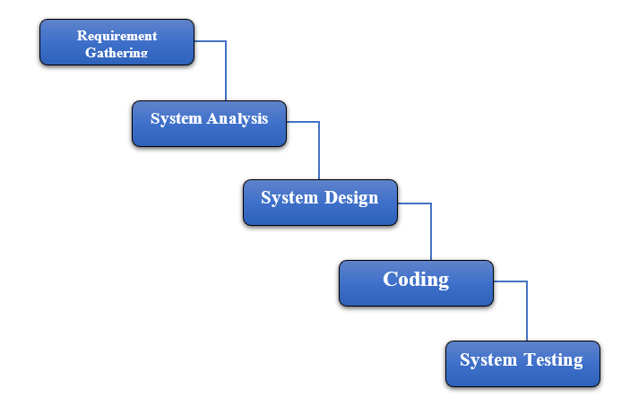

The waterfall model is a classical model used in system development life cycle to create a system with a linear and sequential approach. The waterfall model is the oldest model and it was proposed by ‘Winston Royce’. This model is divided into different phases and the output of one phase is used as the input of the next phase.

Every phase has to be completed before the next phase starts and there is no overlapping of the phases.

The phases in waterfall model are: 1) Requirement Gathering, 2) System Analysis, 3) System Design, 4) Coding, 5) System Testing.

**3.3 Conceptual Models:**

* + 1. **Entity Relationship Diagram:**

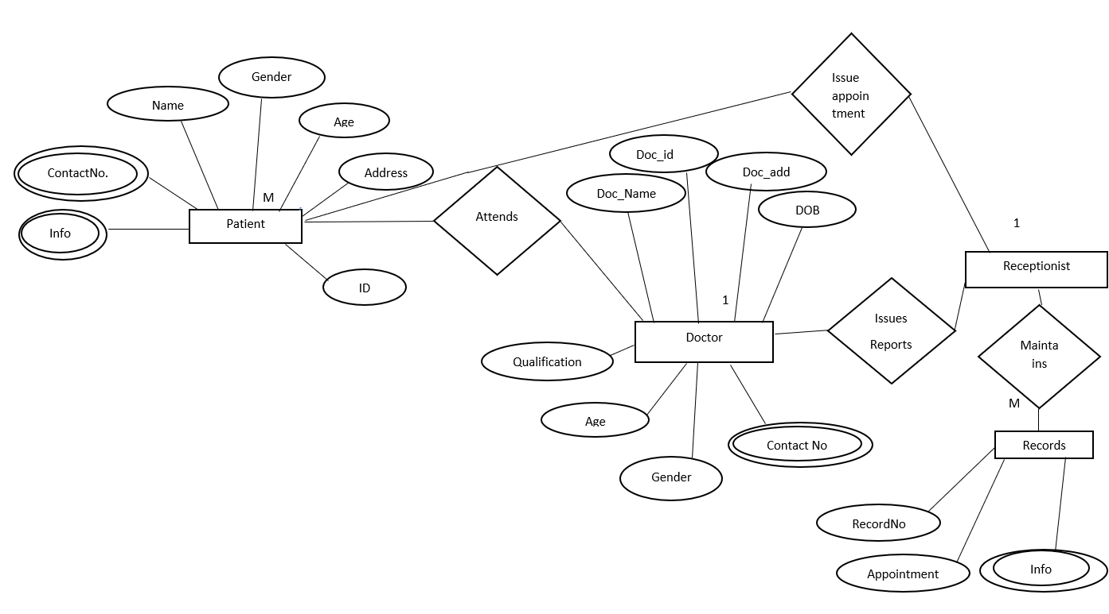

An entity relationship model, also called as entity-relationship diagram, is a graphical representation of entities and their relationship to each other, typically used in computing in regard to the organization of data within databases or information systems. It shows the attributes in tables of the database. The entity-relationship data shows representation of database tables and the relations between patient, Doctor and the receptionist.

Components of ER Diagram:

1. Entity:

An Entity is an object or component of data. Any Entity is represented as **rectangle** in an ER Diagram

Entity

1. Attribute:

An attribute describes the property of an entity. An attribute is represented as **Oval** in an ER Diagram.

1. Relationship:

A relationship in ER Diagram is used to describe the relation between two or more entities. It is represented by a **Diamond** shape in the ER Diagram.

Relationship

* + 1. **Sequence Diagram:**

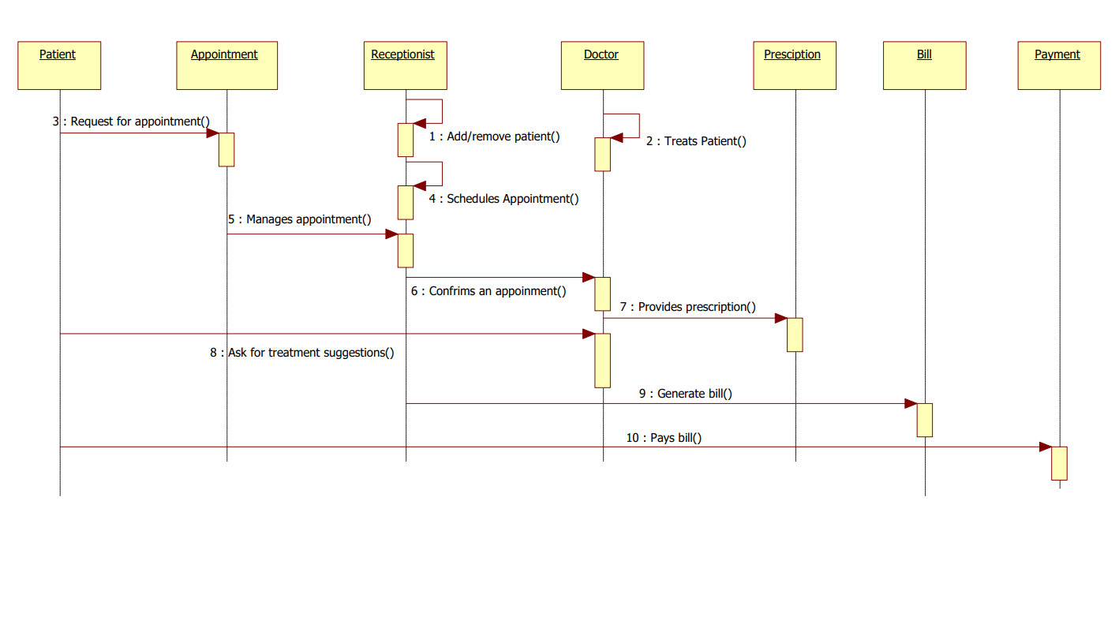

The sequence diagram represents the flow of messages in the system and is also called as an event diagram. The sequence diagram shows the interaction login between the objects of clinic, appointments, patients, receptionists.

Components Of Sequence Diagram:

1. Object:

The object represents how an object will behave in the system. It is represented by Rectangle.

Object

1. Activation box:

It represents the time needed for an object to complete a task. The longer the task will take, the longer the activation box becomes.

1. Actor:

It shows entities that interact with or are external to the system.

* + 1. **Use Case Diagram:**

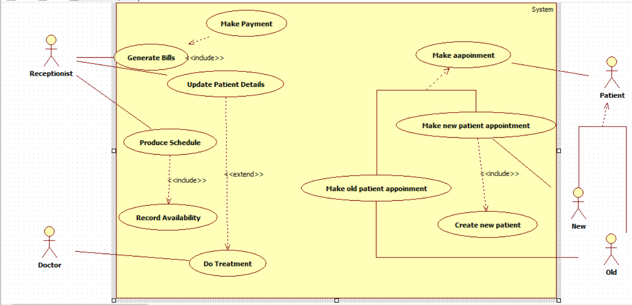

A use case diagram is a graphic depiction of the interactions among the elements of a system. A use case is a methodology used in system analysis to identify, clarify, and organize system requirements. The actors, usually individuals involved with the system defined according to their roles.

The patient can perform, make an appointment and the receptionist can perform, can generate bills, produce schedule and update patients.

Components Of Use Case Diagram:

1. Actor:

An actor is any entity that perform certain roles in a given system. The different roles the actor represents are the actual business roles of users in a given system.

Actor

1. Use Case:

A use case in a use case diagram is a visual representation of a functionality in a system. It is represented by an **Oval**.

1. System Boundary:

A system boundary defines the scope of what a system will be. The system boundary is represented as a **Rectangle** with all the use cases inside in the system boundary.

System Boundary

* + 1. **Activity Diagram:**

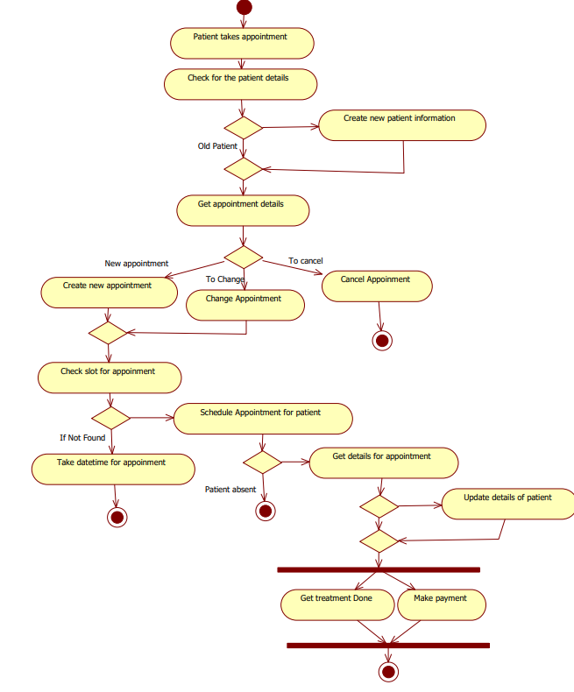

An activity diagram is an UML diagram which describes the aspects of the system. It is basically a flowchart diagram which describes the flow from one activity to other activity. It is also described as an operation of the system. The flow in the diagram can be sequential, branched and concurrent. It shows the flows between the activity of patient, receptionist and the doctor.

The activities are as follows: Patient activity, Doctors activity, Receptionist activity.

Components Of Activity Diagram:

1. Action:

A step in the Activity Diagram wherein the users or software perform a given task. It is presented by **Rounded-Rectangle**.

Action

1. **Decision node:**

A conditional branch in the flow includes a single input and two or more outputs. It is represented by a **Diamond**.

Decision

1. Connectors:

It is also known as connectors that show the flow between steps in the Activity Diagram. It is represented by an **Arrow**.

1. **Start node:**

It shows the beginning of the activity. The start node is represented by a **Black Circle** in Activity Diagram.

1. **End node:**

**It** represents the final step in the activity. The end node is represented by an **Outlined Black Circle**.

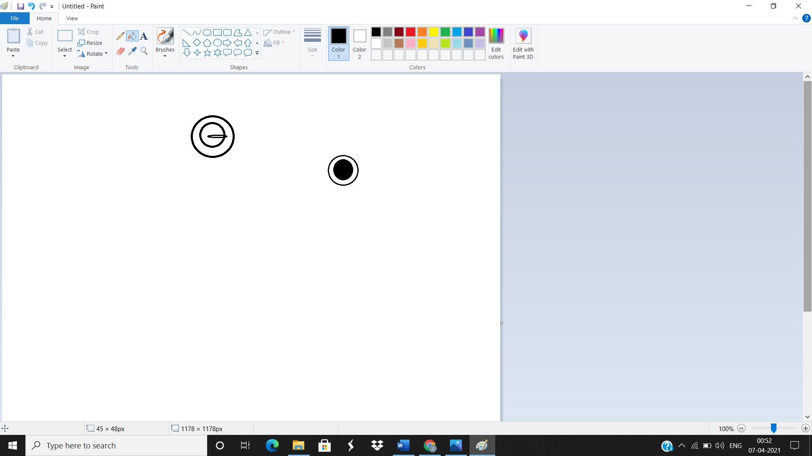

* + 1. **Class Diagram:**

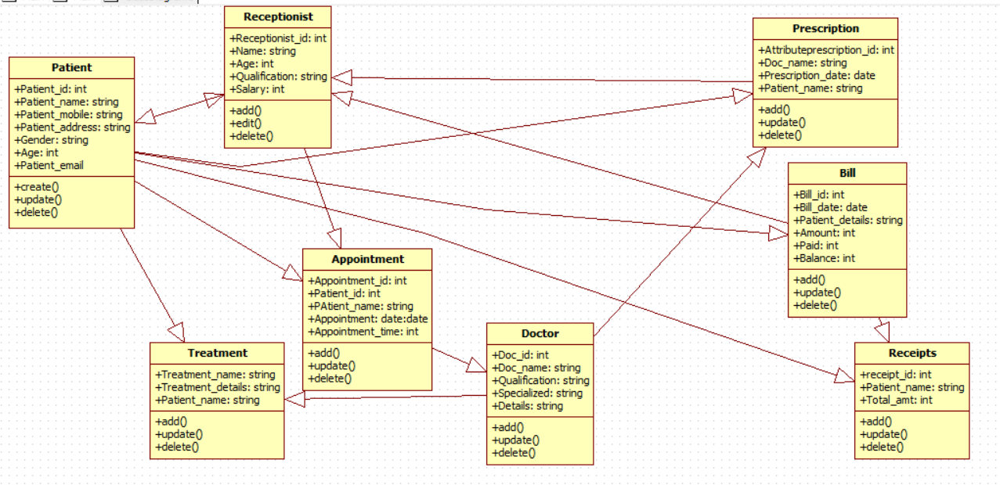

A class diagram in the Unified Modelling Language (UML) by showing

is a type of static structure diagram the describes the structure of a system

showing the system’s classes, their attributes, operations, and the

relationship among objects.

The main classes are Patient, Receptionist, Doctor, Treatment and Treatment.

Components Of Class Diagram:

1. Class:

A Class represents a relevant concept from domain, a set of persons, objects, or ideas that are depicted in the system.

Class

Attribute

1. Attribute:

An Attribute of a class represents a characteristic of class that is of interest for the user of the system.

Class

Attribute

1. Generalization:

Generalization is a relationship between two classes that a general class and a special class. It is represented by an **Arrow**.

1. Association:

An association represents a relationship between two classes:

An Association indicates that objects of one class have a relationship with objects of another class, in which the connection has a specifically defined meaning.

**3.3.6** **Data Flow Diagram:**

A data flow diagram is a graphical representation of the flow of data through an information system. It shows how information is input to and output from the system, the sources and destinations of that information, and where that information is stored

LEVEL 0:

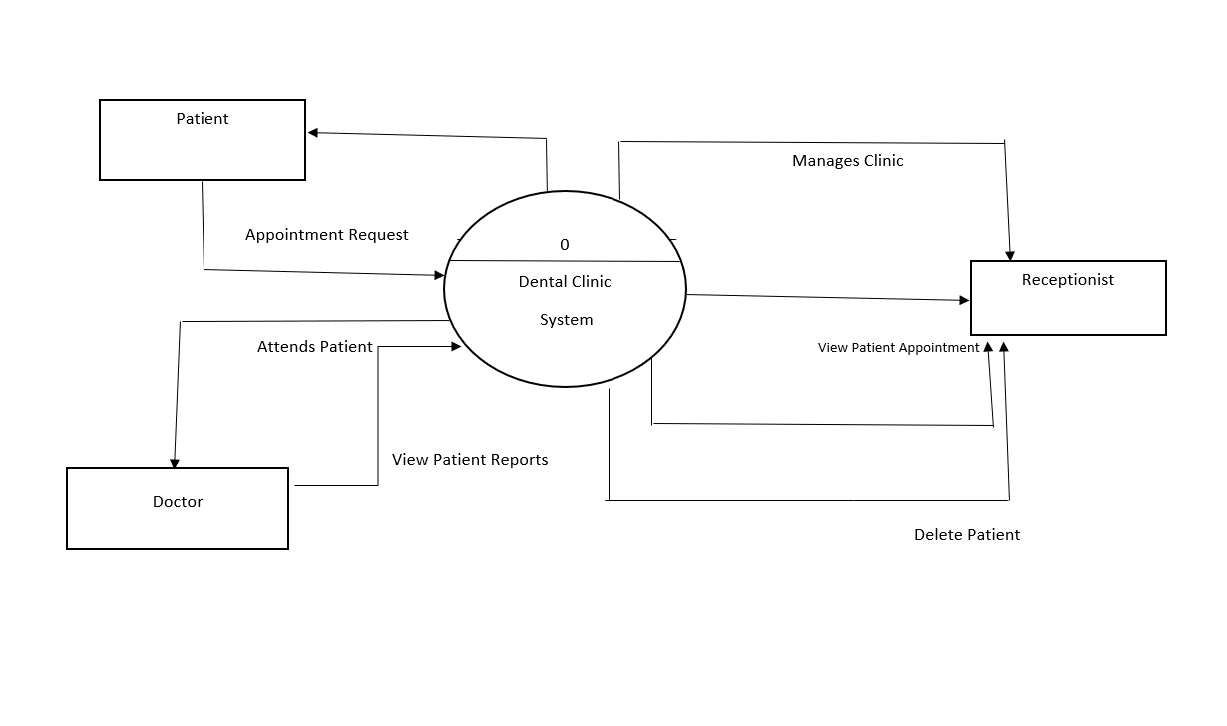

Highest abstraction level DFD is known as level 0 DFD, which depicts the entire information system as one diagram concealing all the underlying details. It is the 0 level DFD of Dental Clinic System, where we have described about the high-level processes of the system.

It represents the overview of a whole system that is being analysed or modelled.

LEVEL 1:

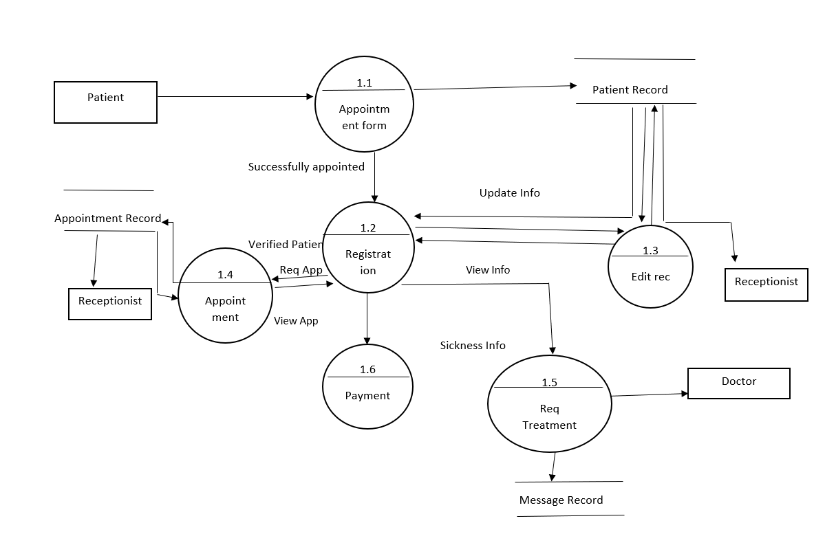

The Level 0 DFD is broken down into more specific, Level 1 DFD. Level 1 DFD depicts basic modules in the system and the flow of data among various modules. Level 1 DFD also mentions the basic processes and sources of information. Level 1 DFD shows how the system is divided into subsystem, each of which deals with one or more of the data flows.

It also shows the internal data stores of Appointment, Receptionist and the Doctor.

Components Of Data Flow Diagram:

1. External Entity:

**It is a**lso known as actors, sources or sinks, and terminators, external entities produce and consume data that flows between the entity and the system.

External Entity

1. **Process**:

An activity that changes or transforms data flows. Since process transform incoming data to outgoing data, all processes must have inputs and outputs on a DFD.

1. **Data Store:**

A data store does not generate any operations but simply holds data for later access.

Data Store

1. **Data Flow**:

Movement of data between external entities, processes and data stores. It is represented with an **Arrow**, which indicates the direction of flow.

* + 1. **Flowchart:**

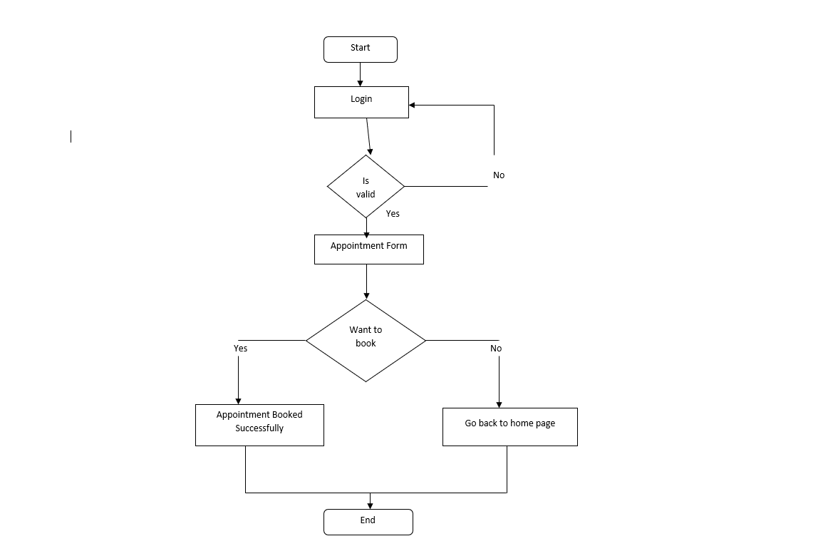

It represents the flow of the system as a whole and also shows how the system will work. It shows the flow from the start to end.

Components Of Flowchart:

1. Start Node and End Node:

The Start Node denotes the start of the system and the End Node denotes the end of the system. It represented by **Rounded Rectangle**.

Start/End

1. Decision Node:

The times when a decision is to be made. It is represented by **Diamond**.

Decision

1. Connector:

It is the **Arrow** which indicates the flow of the system.

* 1. **Planning and Scheduling:**

**3.4.1 Gantt Chart:**

A Gantt chart is a graphical depiction of a project schedule. It's is a type of bar chart that shows the start and finish dates of several elements of a project that include resources, milestones, tasks, and dependencies.

The preparation of this Gantt Chart for the development of “Dental Clinic System” starts from August and ends in February.

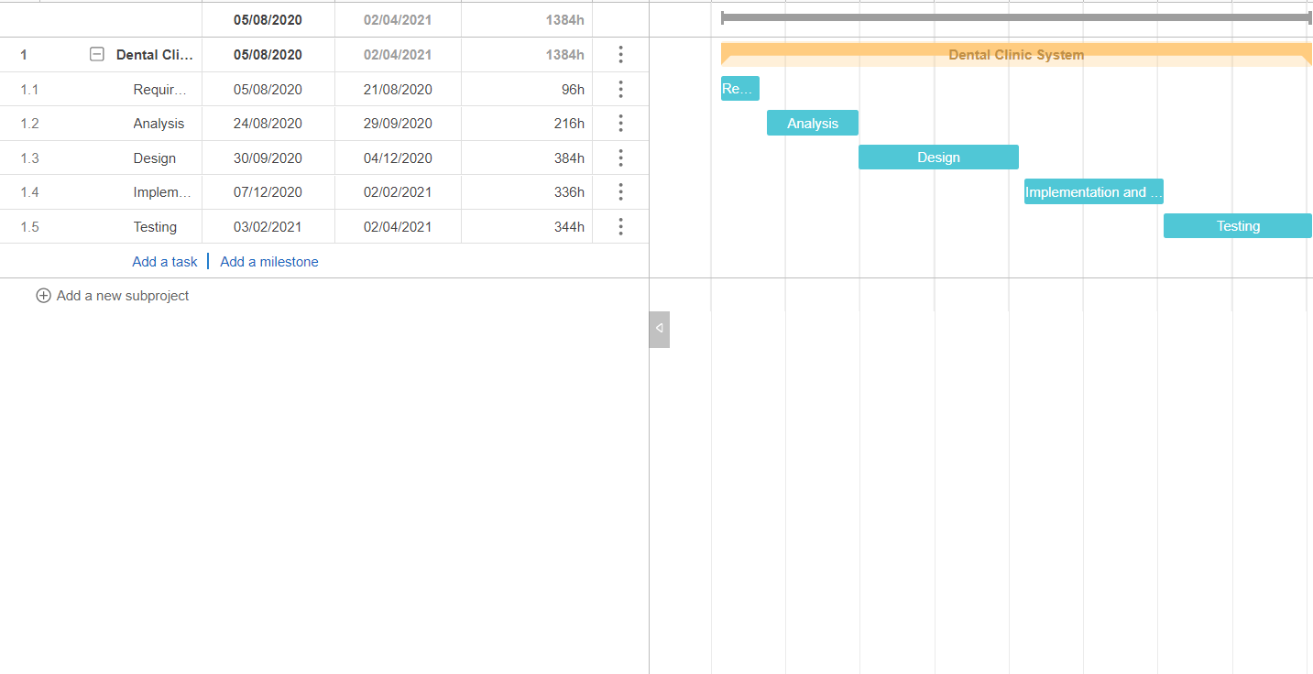

**3.4.2 Pert Chart:**

Pert (Program Evaluation and Review Technique) will calculate the time duration for each and every task. It also takes into consideration the risk involve in the project.

Pert requires three estimates:

1. Optimistic Estimate: Estimate when all favourable things will happen (all opportunities happen and no threats take place).
2. Pessimistic Estimate: Estimate when all unfavourable conditions happen (all threats happen and no opportunities take place).
3. Most Likely Estimate: Estimate when both favourable and unfavourable conditions will happen.

|  |  |  |  |  |  |  |
| --- | --- | --- | --- | --- | --- | --- |
| Activity | Depends On | Optimistic | Most Likely | Pessimistic | Expected Duration | Standard Deviation |
| Requirement(A) | - | 3 | 5 | 6 | 4.8333 | 0.5000 |
| Analysis(B) | A | 4 | 7 | 10 | 7.0000 | 1.0000 |
| Design(C) | B | 5 | 10 | 7 | 8.6667 | 0.3333 |
| Implementation  And Coding (D) | C | 8 | 15 | 20 | 14.6667 | 2.0000 |
| Testing(E) | D | 10 | 12 | 14 | 12.0000 | 0.6667 |

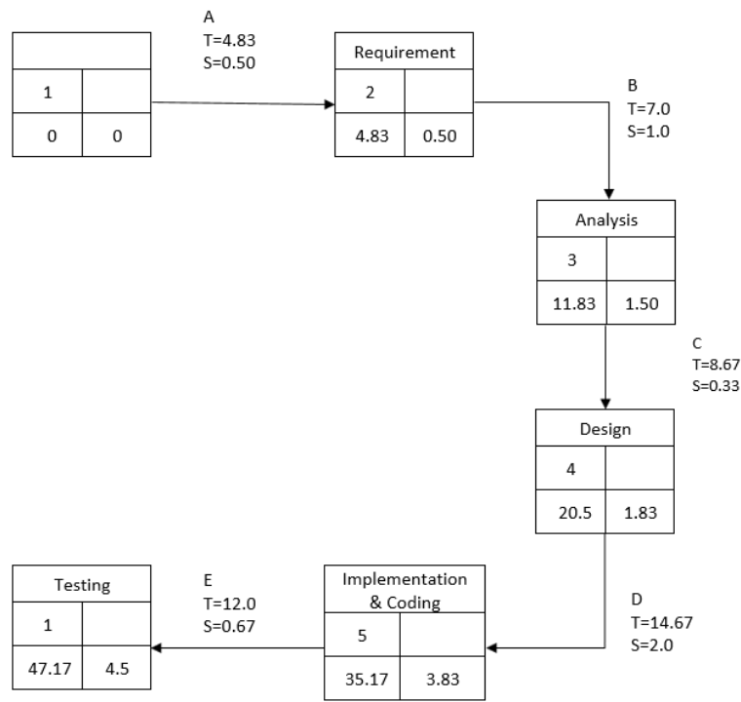

* 1. **Software and Hardware:**

**3.5.1 Software:**

* Windows 10.
* Visual Studio (2015).
* MySQL Server.

**CHAPTER:4 SYSTEM DESIGNING**

**4.1 Pseudo Code:**

Login:

Begin

if(user)

{

appointment page;

}

else if(admin)

{

dashboard page;

}

else

{

Invalid Phone no. and Password

}

end if

* 1. **Software Testing:**

Software Testing is a method to check whether the actual software product matches expected requirements of the user and the software is free from defects. Testing is conducted at the phase level in software development life cycle or at module level in program code.  The purpose of software testing is to identify errors, gaps or missing requirements in contrast to actual requirements.

**Software Testing is important** because if there are any bugs or errors in the software, it can be identified early and can be solved before delivery of the software product.

Software Testing involves execution of software or system using manual or automated tools.

* 1. **Design:**

**Home page:**

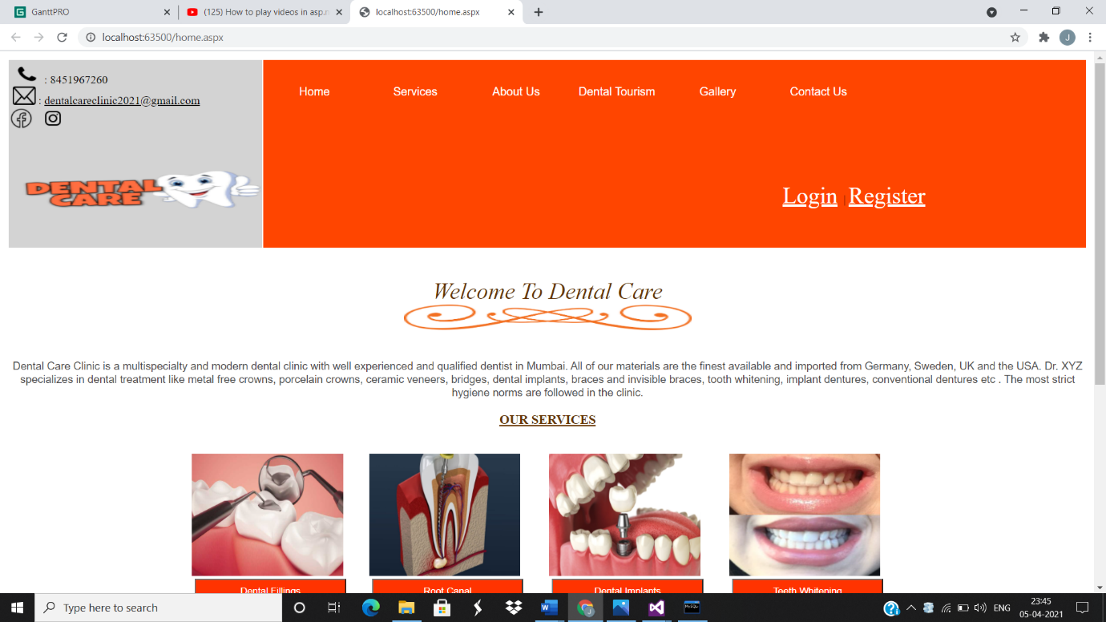

**Services Pages:**

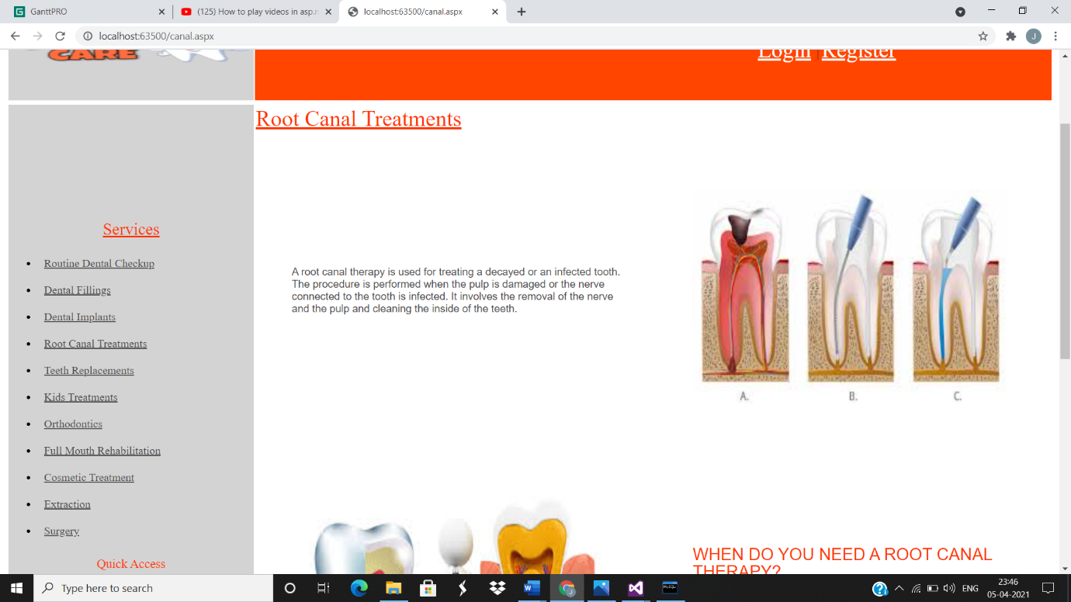

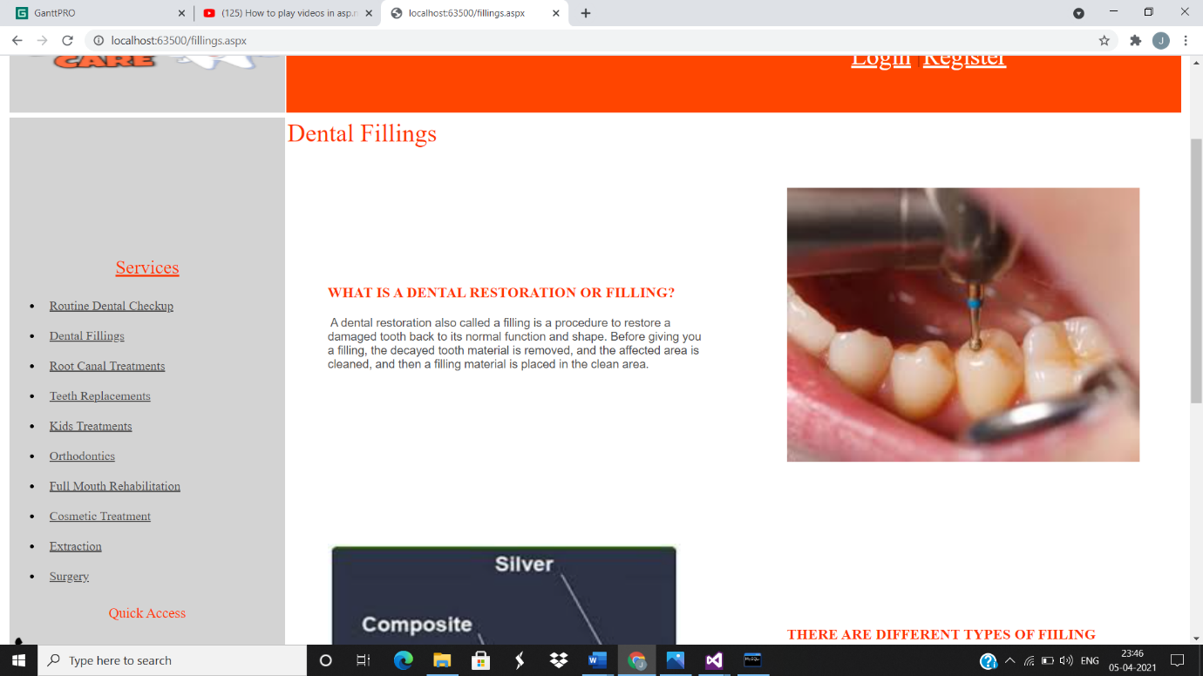

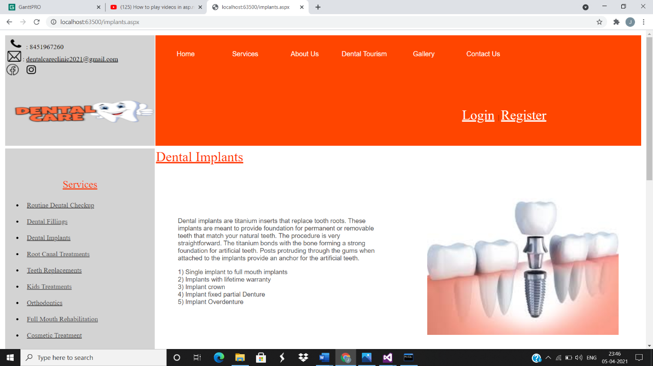

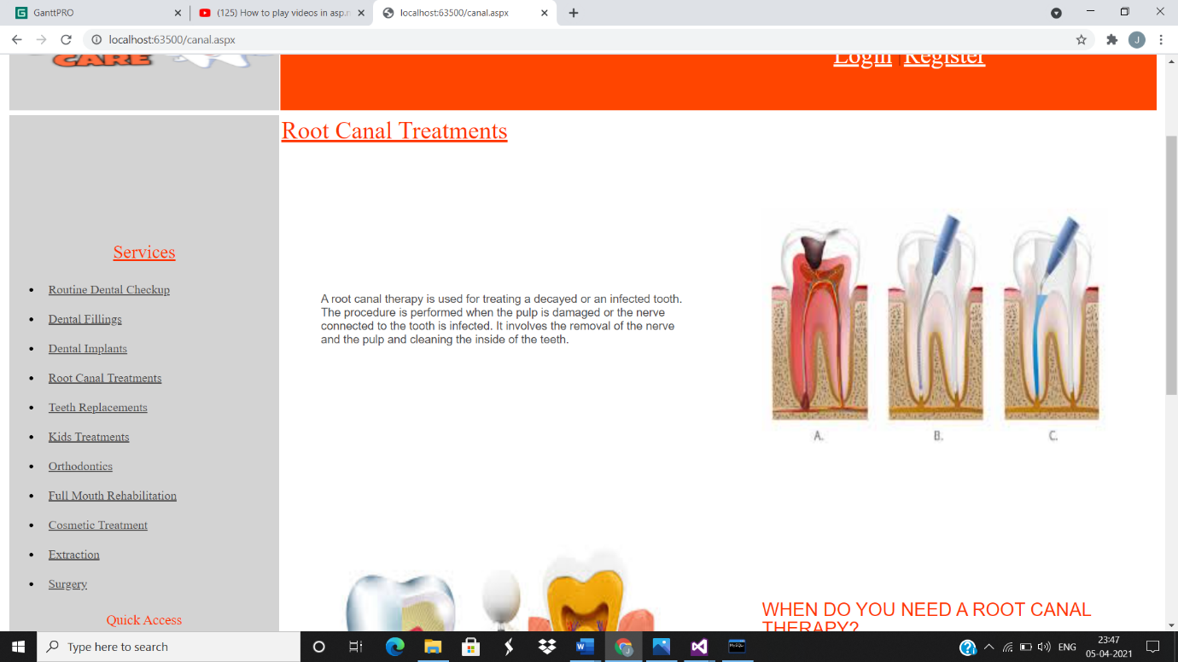

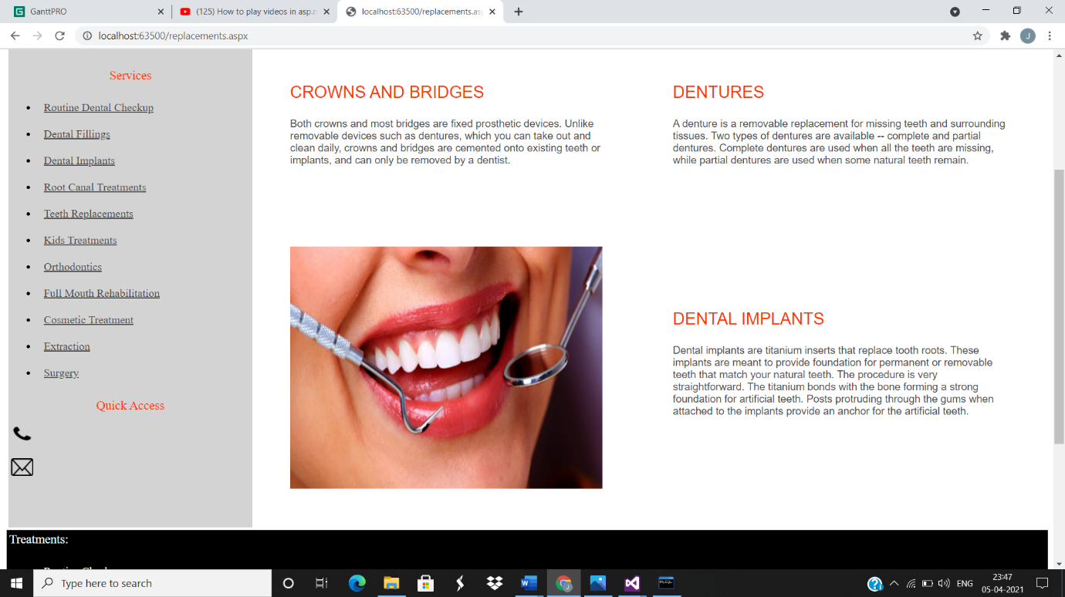

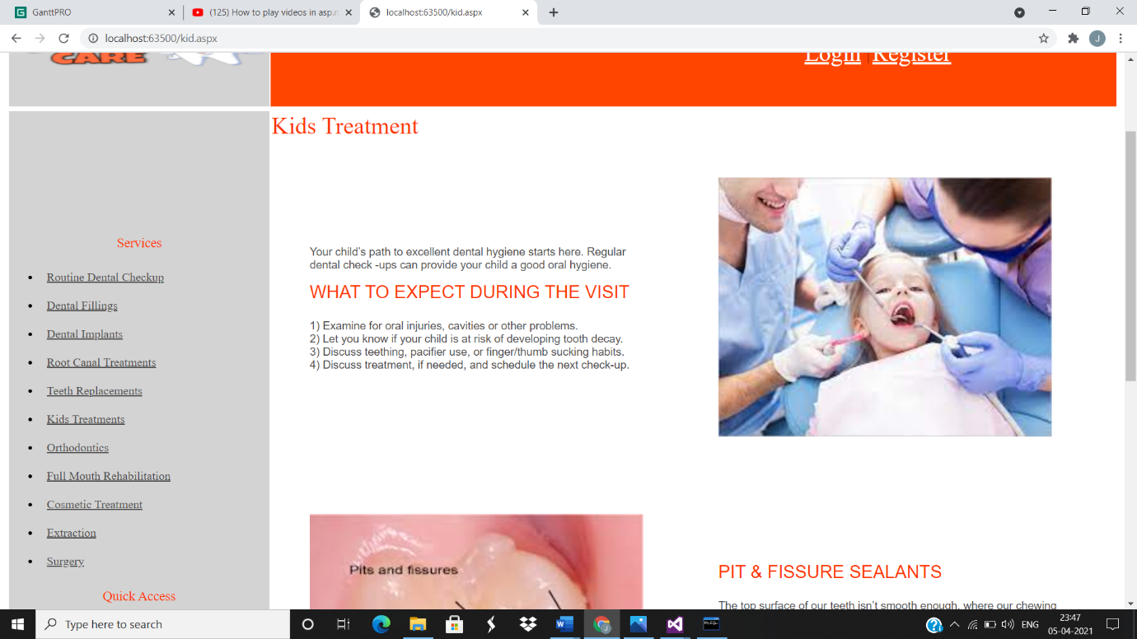

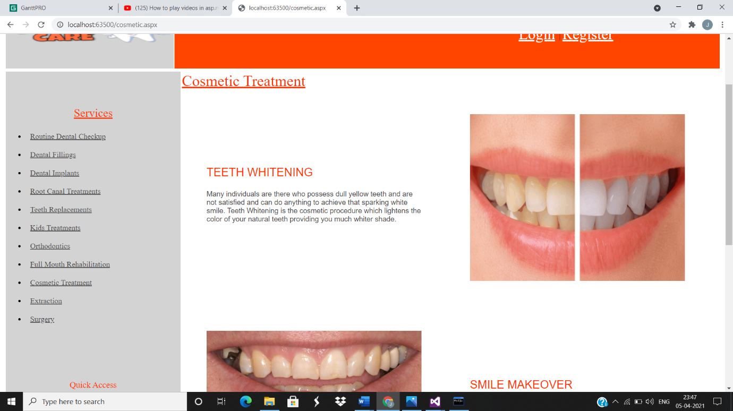

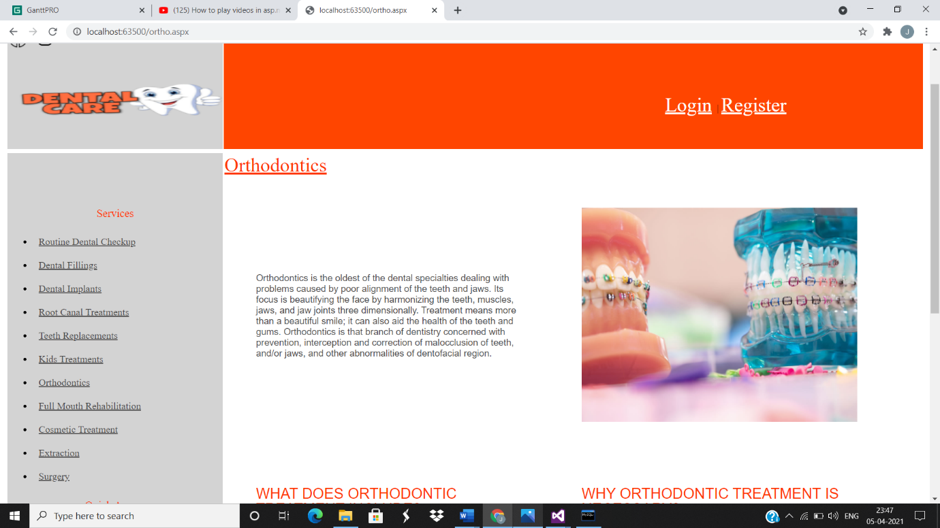

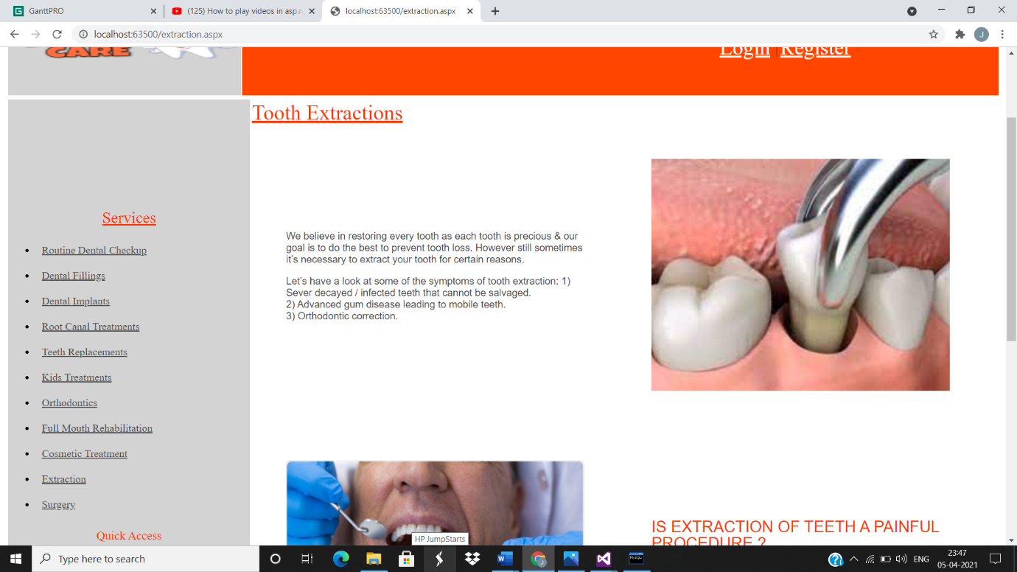

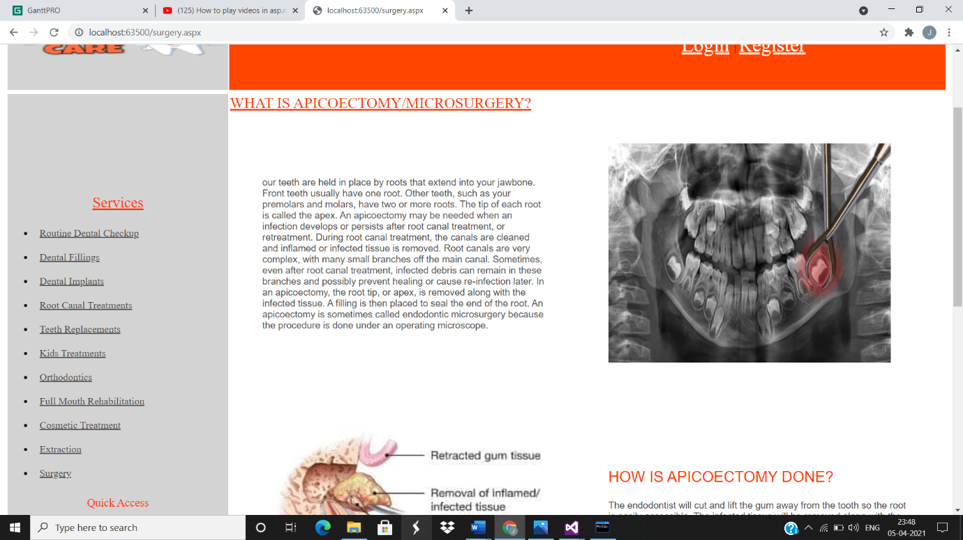

**Photo Gallery Page:**

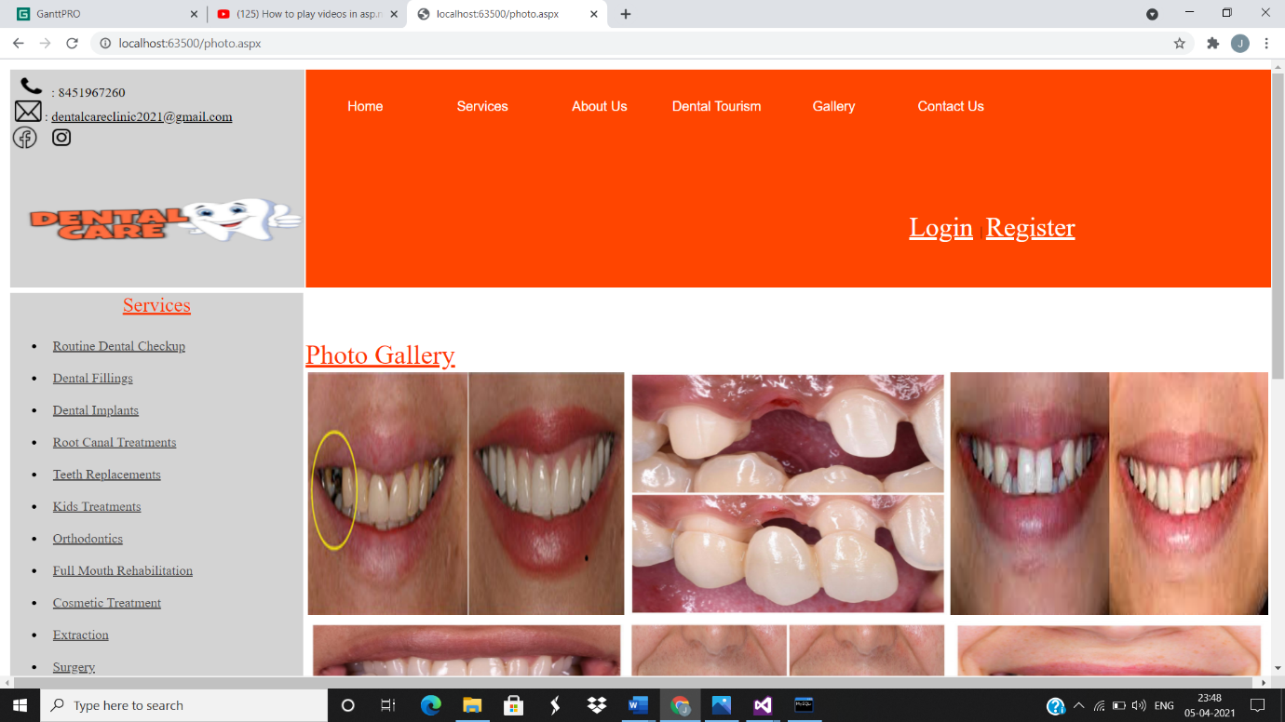

**Contact Us Page:**

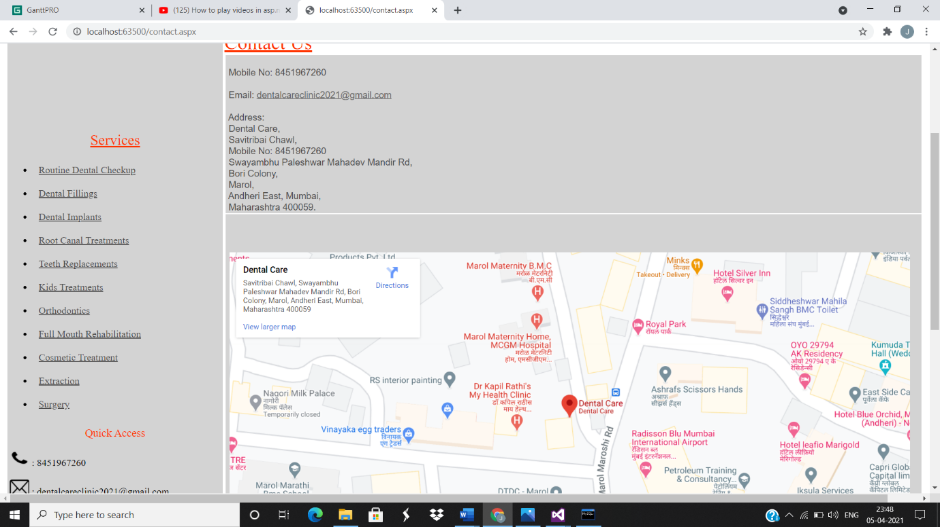

**Video Gallery Page:**

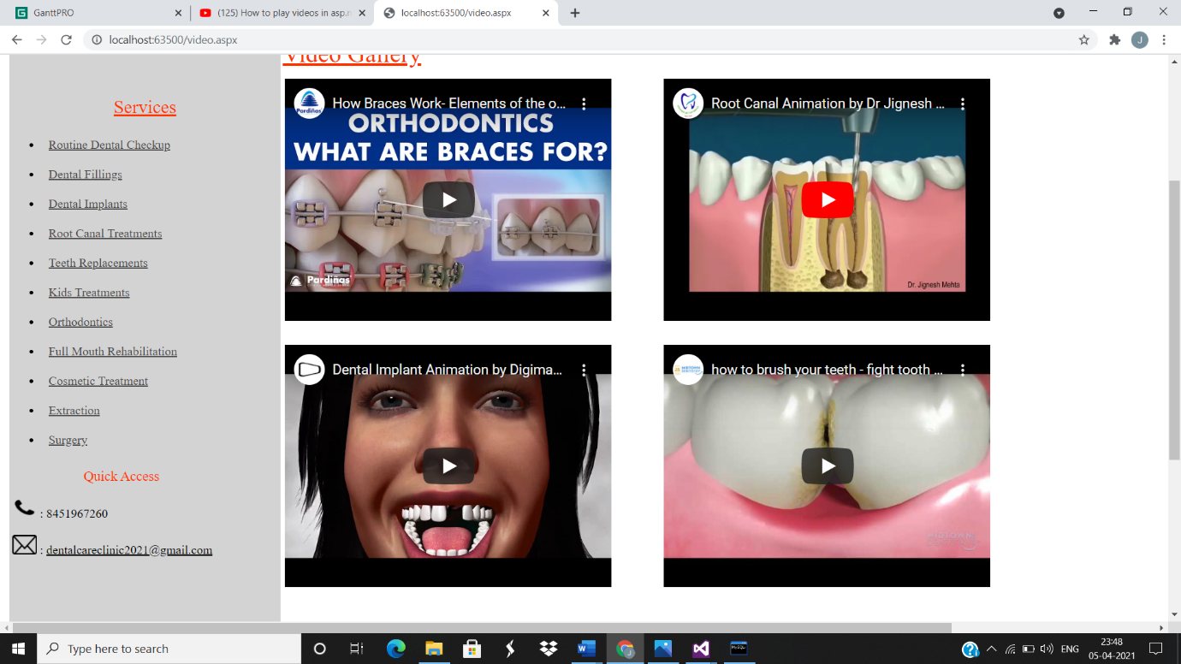

**Aim and Vision Page:**

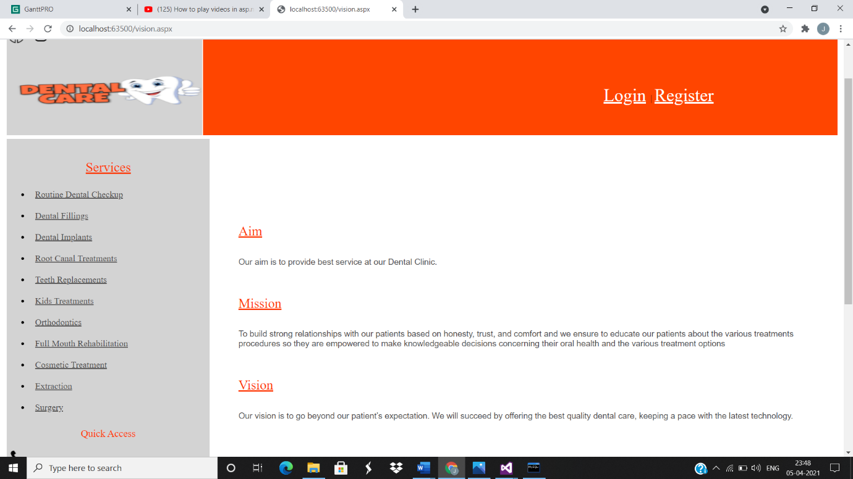

**Tourism Page:**

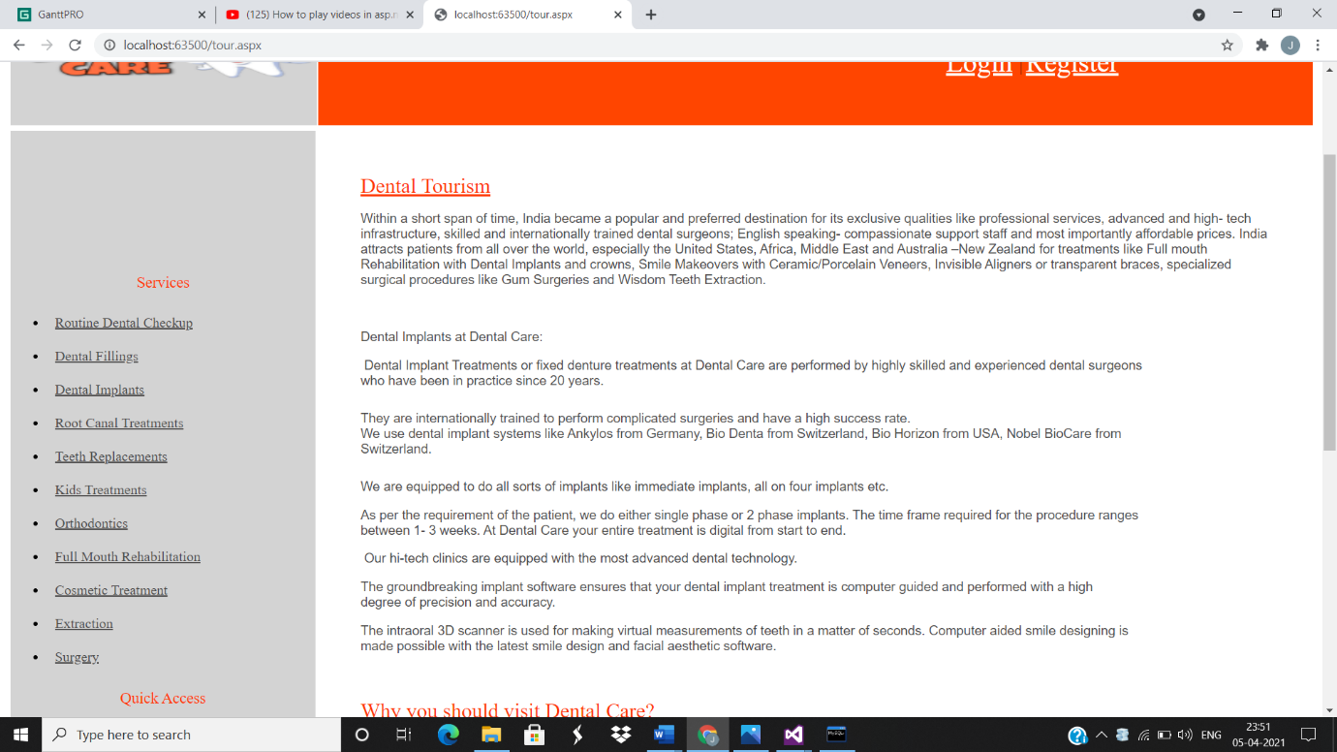

**Login Page:**

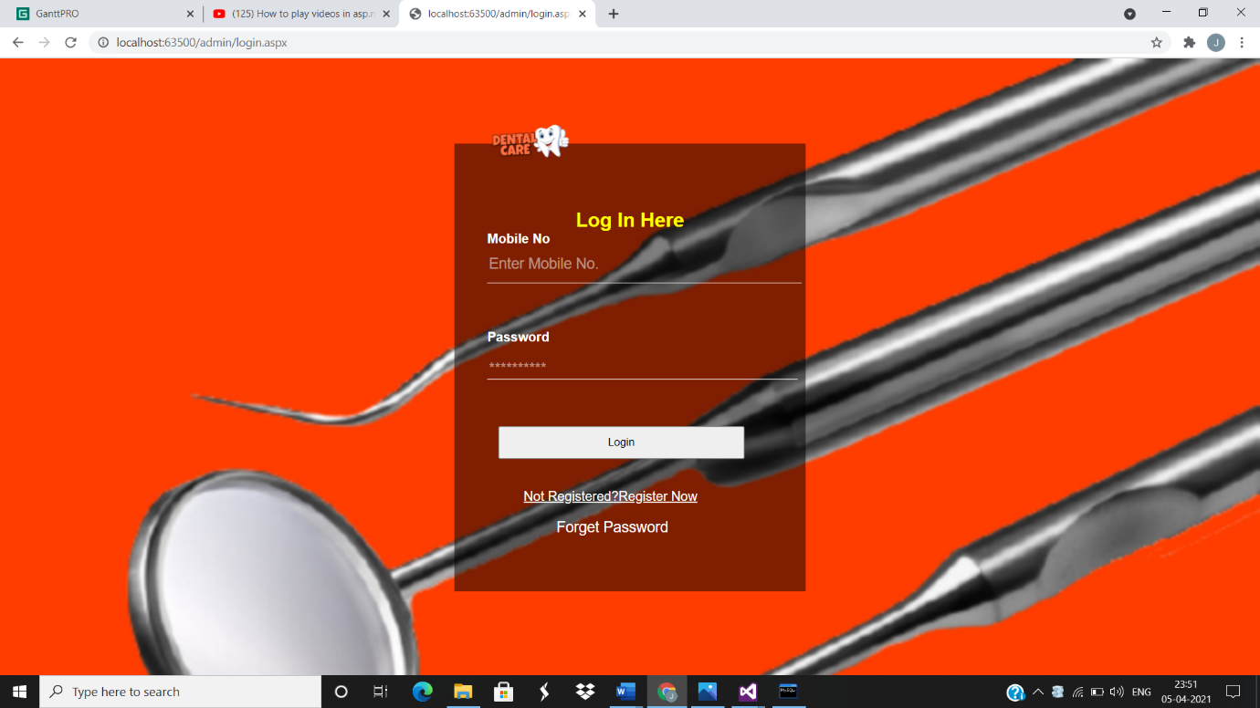

**Registration Page:**

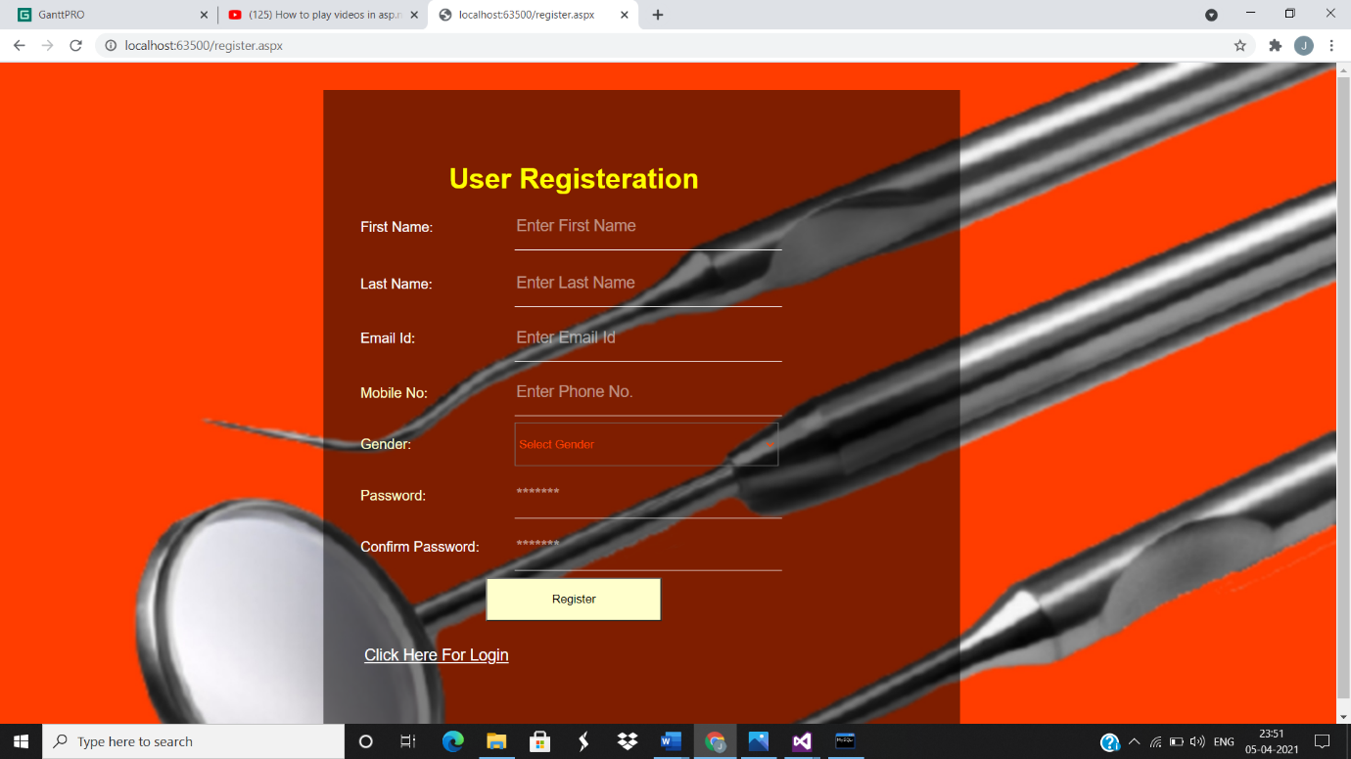

**Appointment Page:**

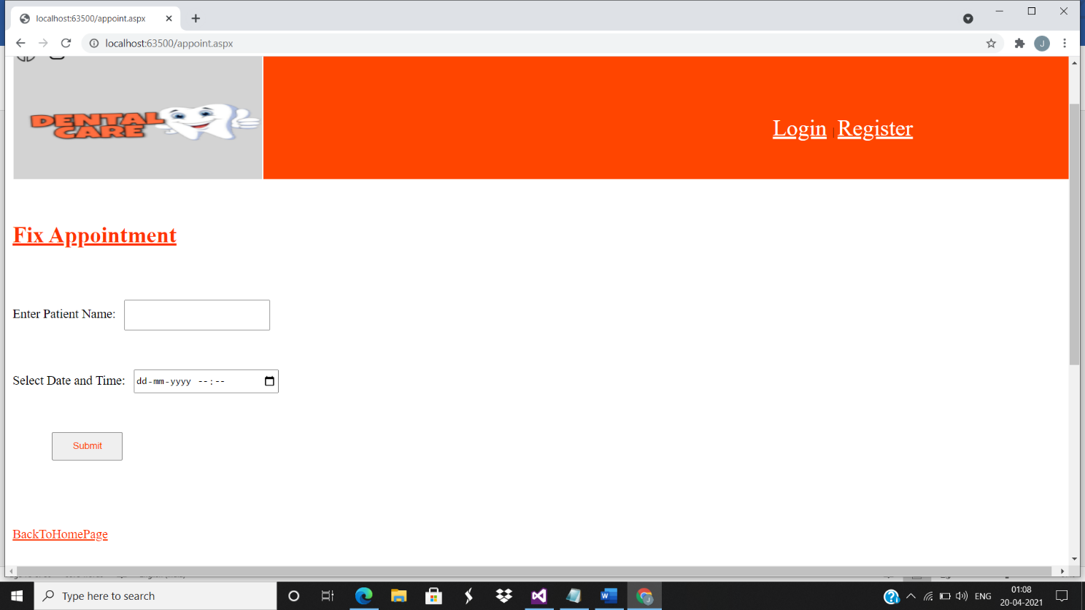

**Admin Dashboard Page:**

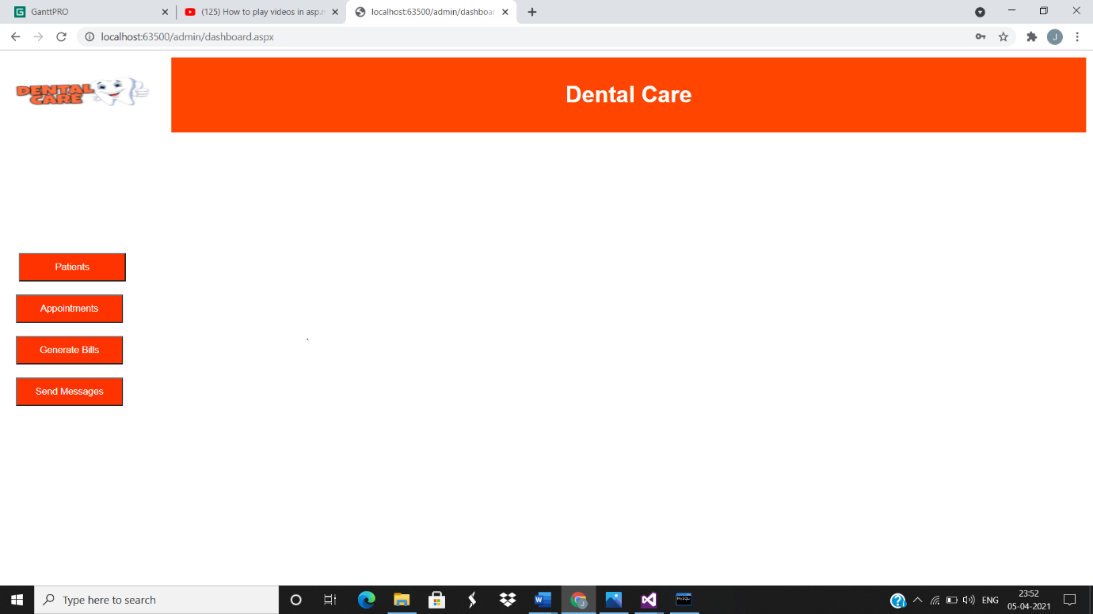

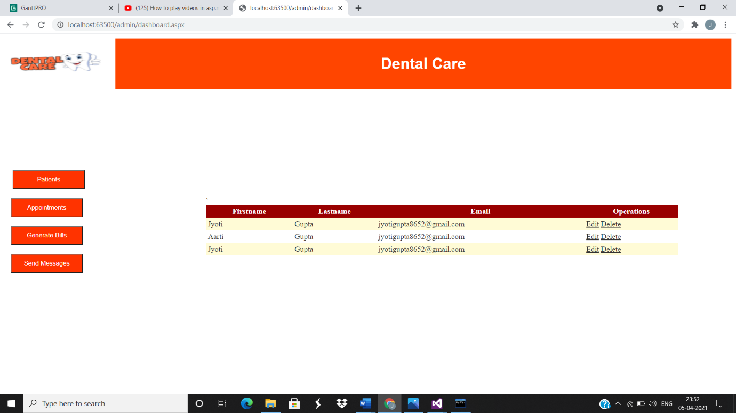

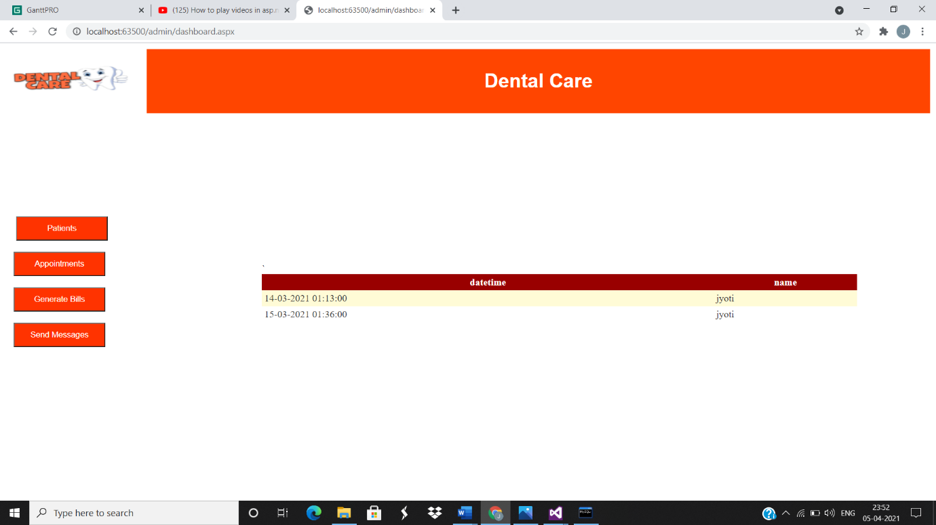

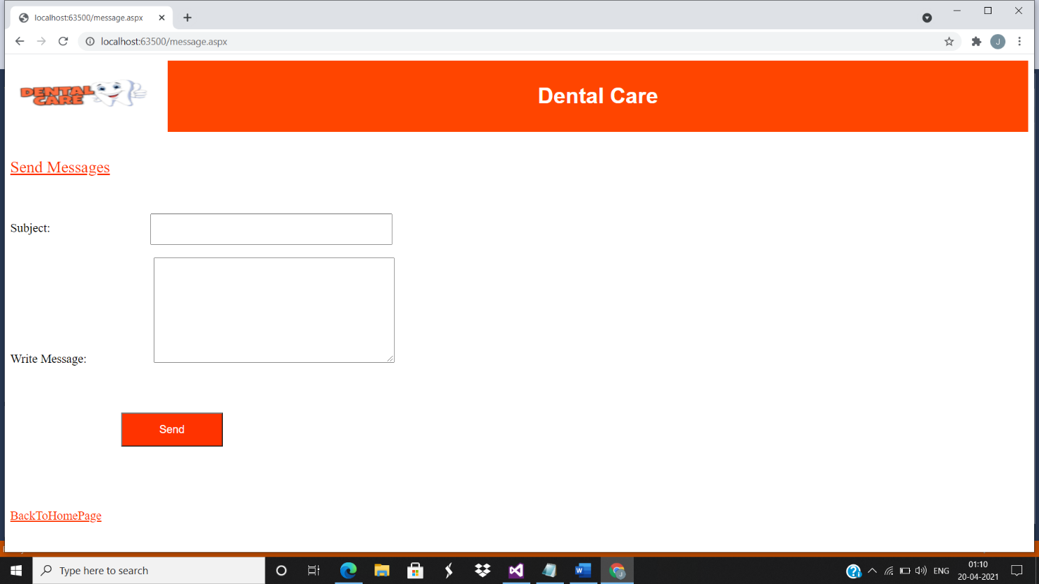

**Patient Bill Page:**

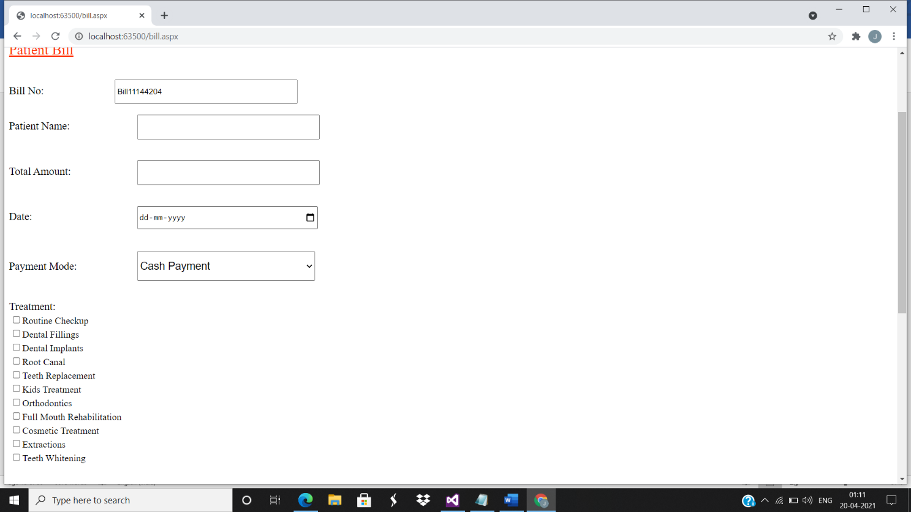

**Invoice:**

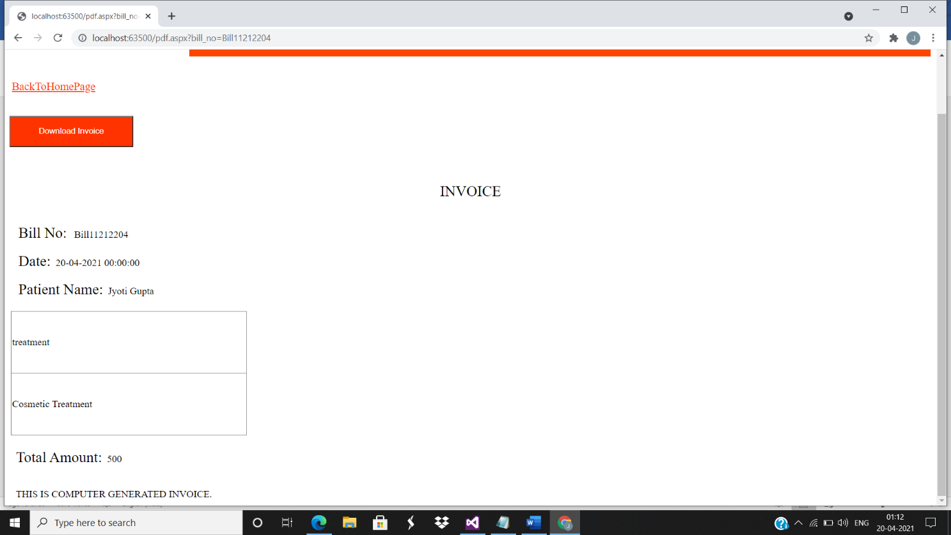

**CHAPTER:5 IMPLEMENTATION AND TESTING**

**5.1 Model:**

**5.1.2 Waterfall Model:**



The waterfall model is a classical model used in system development life cycle to create a system with a linear and sequential approach. The waterfall model is the oldest model and it was proposed by ‘Winston Royce’.

This model is divided into different phases and the output of one phase is used as the input of the next phase. Every phase has to be completed before the next phase starts and there is no overlapping of the phases.

The phases in waterfall model are: 1) Requirement Gathering, 2) System Analysis, 3) System Design, 4) Coding, 5) System Testing.

**5.2 Coding:**

**Login:**

using System;

using System.Collections.Generic;

using System.Linq;

using System.Web;

using System.Web.UI;

using System.Web.UI.WebControls;

using System.Data;

using MySql.Data.MySqlClient;

using MySql.Data;

using MySql.Data.Types;

namespace Integration.admin

{

public partial class login : System.Web.UI.Page

{

protected void Page_Load(object sender, EventArgs e)

{

UnobtrusiveValidationMode = UnobtrusiveValidationMode.None;

Label3.Visible = false;

}

protected void Button2_Click(object sender, EventArgs e)

{

string connectionString;

object obj;

connectionString = "server=localhost;port=3307;user=root;database=dentalcare;password=Jyoti_8451;pooling=false";

MySqlConnection conn = new MySqlConnection(connectionString);

conn.Open();

try

{

MySqlCommand cmd = new MySqlCommand("SELECT category FROM register WHERE phone=@phone AND password=@password", conn);

cmd.CommandType = System.Data.CommandType.Text;

cmd.Parameters.AddWithValue("@phone", TextBox1.Text);

cmd.Parameters.AddWithValue("@password", TextBox2.Text);

// int count = Convert.ToInt32(cmd.ExecuteNonQuery());

// String category = Convert.ToString(cmd.ExecuteReader());

obj = cmd.ExecuteScalar();

if (Convert.ToString(obj).Equals("user"))

{

Response.Redirect("~/appointment.aspx", false);

Context.ApplicationInstance.CompleteRequest();

}

else if (Convert.ToString(obj).Equals("Admin"))

{

Response.Redirect("~/dashboard.aspx", false);

Context.ApplicationInstance.CompleteRequest();

}

else

{

Label3.Visible = true;

}

}

catch (Exception ex)

{

Console.Write("Exception : " + ex.StackTrace);

}

finally

{

conn.Close();

}

}

}

}

**Registration:**

using System;

using System.Collections.Generic;

using System.Linq;

using System.Web;

using System.Web.UI;

using System.Web.UI.WebControls;

using MySql.Data.MySqlClient;

using MySql.Data;

using MySql.Data.Types;

using System.Data;

namespace Integration

{

public partial class register : System.Web.UI.Page

{

protected void Page_Load(object sender, EventArgs e)

{

UnobtrusiveValidationMode = UnobtrusiveValidationMode.None;

}

protected void Button1_Click(object sender, EventArgs e)

{

try

{

string connectionString;

//connectionString = "SERVER=localhost;" + "DATABASE=dentalcare; " +"UID=root;" + "PASSWORD=Jyoti_8451;";

connectionString = "server=localhost;port=3307;user=root;database=dentalcare;password=Jyoti_8451;pooling=false";

MySqlConnection conn = new MySqlConnection(connectionString);

// SqlConnection conn = new SqlConnection("Data Source=. ; Initial Catalog=dentalcare; Integrated Security=True");

conn.Open();

//SqlCommand cmd = new SqlCommand("insert into register" + "(firstname,lastname,email,phone,gender,password) values (@fname,@lname,@email,@phone,@gender,@password)", conn);

MySqlCommand cmd = new MySqlCommand("insert into register" + "(firstname,lastname,email,phone,gender,password,category) values (@fname,@lname,@email,@phone,@gender,@password,'user')", conn);

cmd.Parameters.AddWithValue("@fname", TextBox1.Text);

cmd.Parameters.AddWithValue("@lname", TextBox2.Text);

cmd.Parameters.AddWithValue("@email", TextBox3.Text);

cmd.Parameters.AddWithValue("@phone", TextBox4.Text);

cmd.Parameters.AddWithValue("@gender", DropDownList1.SelectedItem.Value);

cmd.Parameters.AddWithValue("@password", TextBox6.Text);

cmd.ExecuteNonQuery();

conn.Close();

Label8.Text = "Registered Successfully";

}

catch (Exception ex)

{

Console.Write("Exception : " + ex.StackTrace);

}

}

}

}

**Appointment:**

using System;

using System.Collections.Generic;

using System.Linq;

using System.Web;

using System.Web.UI;

using System.Web.UI.WebControls;

using System.Data;

using MySql.Data.MySqlClient;

using MySql.Data;

using MySql.Data.Types;

namespace Integration

{

public partial class appointment : System.Web.UI.Page

{

protected void Page_Load(object sender, EventArgs e)

{

UnobtrusiveValidationMode = UnobtrusiveValidationMode.None;

}

protected void Button2_Click(object sender, EventArgs e)

{

try

{

string connectionString;

connectionString = "server=localhost;port=3307;user=root;database=dentalcare;password=Jyoti_8451;pooling=false";

MySqlConnection conn = new MySqlConnection(connectionString);

conn.Open();

MySqlCommand cmd = new MySqlCommand("insert into appoint" + "(datetime,name) values (@datetime,@name)", conn);

cmd.Parameters.AddWithValue("@datetime", TextBox2.Text);

cmd.Parameters.AddWithValue("@name", TextBox1.Text);

cmd.ExecuteNonQuery();

Label7.Text = "Appointment Fixed";

conn.Close();

}

catch (Exception ex)

{

Console.Write("Exception : " + ex.StackTrace);

}

}

}

}

**5.3 Testing Approaches:**

**5.3.1 Unit Testing:**

Unit is the smallest part of the software which is testable.

The purpose is to validate that each unit of the software code performs as expected.

Unit Testing is done during the development of an application by the developers.

Unit Testing performed by software developers themselves or their peers.

Unit testing increases confidence in changing or maintaining code.

**5.3.2 Whitebox Testing:**

**White Box Testing** is software testing technique in which internal structure, design and coding of software are tested to verify flow of input-output and to improve design, usability and security.

 White Box Testing tests internal coding and infrastructure of a software focus on checking of predefined inputs against expected and desired outputs.

The white box testing is also known as clear box or transparent box.

The clear box or white box or transparent box name denote the ability to see through the software's outer shell into its inner workings.

The developers perform the white box testing and then send the software to the testing team.

**5.3.3 Error Handling Testing:**

Error handling testing is a type of software testing that is performed to check whether the system is able to handle the errors that may happen in future.

This type of testing is basically performed with the help of both developers and the testers.

Application is expected to help user through error messages, if anything unexpected happens with the system.

Error handling has a direct relationship with usability of an application, and a distant relationship with the security of the system.

Error handling testing not only focuses on the determination of error but also focuses on the exception handling.

When user tries to enter the wrong data, the system identifies the wrong entry and prevents such entry in the system.

In this web-based application the suggestive messages are used in registration and login page:

1. If the user enters invalid email address than the messages arises as “Invalid Email Address”.
2. If the user enters a password range less than 8 characters than the message arises as “Password should be at least 8 characters in length and contain at least one digit, one lowercase, one uppercase character and one special character (i.e. ! @ # &).”.

**5.3.4 Graphical User Interface Testing:**

Graphical User Interface is most important part of the application along with the functionality. Graphical User Interface is also known as ‘GUI’ or ‘UI’ Testing. Other than the system type of software, most of the application have the user interface from where a user interacts with the system. Graphical User Interface Testing includes the following:

All colours used in background, control colours and font colours have major impact on the user.

All words, fonts and alignment used on the screen which would be read when the user is interacting with the application.

Error messages and the information given to the user must be usable to the user. Message must guide the user to perform the correct action.

**5.3.5 System Testing:**

System Testing represents the final testing done on a system before it is delivered to the customer. System testing validates that the entire system meets its functional/non-functional requirement as defined by the customer in software requirement specification. The criteria for system testing may involve an entire domain or selected part depending upon the scope of the testing.

System testing goes through the following stages that is, Functional testing and User Interface Testing. Functional Testing intends to find whether all the function as per the requirement definition working or not.

User Interface Testing may involve colours, navigations, spellings and fonts.

**5.4 Test Cases:**

|  |  |  |  |  |  |
| --- | --- | --- | --- | --- | --- |
| **Test Case** | **Priority** | **Test Case/Objective** | **Step/Procedure** | **Input Test Data** | **Expected Result** |
| TC01 | P1 | Adding a numeric value to the first name | Enter digits and click ‘Register Button’ | Any numeric value | First name should contain alphabets. |
| TC02 | P1 | Adding a numeric value to the last name | Enter digits and click ‘Register Button’ | Any numeric value | Last name should contain alphabets |
| TC03 | P1 | Adding multiple dots to the email id. | Enter multiple dots and click ‘Register Button’ | Dot Character  value | Invalid Email Address. |
| TC04 | P1 | Not adding ‘@’ character to the email id | Do not enter ‘@’ character and click ‘Register Button’ | ‘@’ character value | Invalid Email Address. |
| TC05 | P1 | Adding invalid mobile number | Enter number less than or more than 10 digits and click ‘Register Button’ | Value less than or more than 10 digits | Must contain at least 10 digits. |
| TC06 | P1 | Entering password | Enter password without one special Character and click ‘Register Button’ | Not to enter a special character | Password should be at least 8 characters in length and contain at least one digit, one lowercase, one uppercase character and one special character (i.e.! @ # &). |
| TC07 | P1 | Entering password | Enter password less than 8 characters and click ‘Register Button’ | Value less than 8 characters | Password should be at least 8 characters in length and contain at least one digit, one lowercase, one uppercase character and one special character (i.e.! @ # &). |
| TC08 | P1 | To verify password | Enter different password from assigned password and click ‘Register Button’ | Password different from assigned password | Password not matching |
| TC09 | P1 | Registering with all the fields blank | Leaving all the fields blank and click ‘Register Button’ | Null | Cannot be blank |
| TC10 | P1 | Verifying the email field by entering a valid email address | Entering valid email address and click ‘Register Button’ | Valid email address | Registered successfully |
| TC11 | P1 | To verify login page by entering valid Phone number and password | Entering a valid Phone number and password after registration | Valid Phone number and password | Logged in successfully and redirected to appointment page |
| TC12 | P1 | To verify login page by adding invalid Phone number and password | Entering an invalid Phone number and password after registration and click  ‘Login Button’ | Invalid Phone number and password | Cannot Be Blank |
| TC13 | P1 | To submit an Appointment Page blank | Leaving all the fields blank and click ‘Submit Button’ | NULL | Cannot Be Blank |
| TC14 | P1 | Adding a numeric value in the name field | Enter digits and click ‘Submit Button’ | Any numeric value | Field cannot contain digits |

**5.5 Modification and Improvements:**

When the Database Software was installed it was not accessing the database from the server the came to know the Port Number was wrong then the Port Number as “3307” was entered and then it accessed the Database dentalcare.

Before for login page I had used email as username but after that I’ve used Phone Number as username.

When I was working with the dashboard page the edit and option was not included for the data accessed from database, I’ve made the changes in dashboard page by adding the edit and delete options.

Example:

If the admin wants to delete or edit the details of the registered patient from the database he/she can delete directly or edit the data using delete and edit option which is provided.

**CHAPTER:6 RESULTS AND DISCUSSION**

**6.1 Test Reports:**

|  |  |  |  |  |  |  |
| --- | --- | --- | --- | --- | --- | --- |
| **Test Case** | **Priority** | **Test Case/Objective** | **Step/Procedure** | **Input Test Data** | **Expected Result** | **Pass/Fail** |
| TC01 | P1 | Adding a numeric value to the first name | Enter digits and click ‘Register Button’ | Any numeric value | First name should contain alphabets. | Fail |
| TC02 | P1 | Adding a numeric value to the last name | Enter digits and click ‘Register Button’ | Any numeric value | Last name should contain alphabets | Fail |
| TC03 | P1 | Adding multiple dots to the email id. | Enter multiple dots and click ‘Register Button’ | Dot Character  value | Invalid Email Address. | Fail |
| TC04 | P1 | Not adding ‘@’ character to the email id | Do not enter ‘@’ character and click ‘Register Button’ | ‘@’ character value | Invalid Email Address. | Fail |
| TC05 | P1 | Adding invalid mobile number | Enter number less than or more than 10 digits and click ‘Register Button’ | Value less than or more than 10 digits | Must contain at least 10 digits. | Fail |
| T06 | P1 | Entering Password | Enter password without one special Character and click ‘Register Button’ | Not to enter a special character | Password should be at least 8 characters in length and contain at least one digit, one lowercase, one uppercase character and one special character (i.e.! @ # &). | Fail |
| TC07 | P1 | Entering password | Enter password less than 8 characters and click ‘Register Button’ | Value less than 8 characters | Password should be at least 8 characters in length and contain at least one digit, one lowercase, one uppercase character and one special character (i.e.! @ # &). | Fail |
| TC08 | P1 | To verify password | Enter different password from assigned password and click ‘Register Button’ | Password different from assigned password | Password not matching | Fail |
| TC09 | P1 | Registering with all the fields blank | Leaving all the fields blank and click ‘Register Button’ | Null | Cannot be blank | Fail |
| TC10 | P1 | Verifying the email field by entering a valid email address | Entering valid email address and click ‘Register Button’ | Valid email address | Registered successfully | Pass |
| TC11 | P1 | To verify login page by entering valid Phone number and password | Entering a valid Phone number and password after registration | Valid Phone number and password | Logged in successfully and redirected to appointment page | Pass |
| TC12 | P1 | To verify login page by adding invalid Phone number and password | Entering an invalid Phone number and password after registration and click  ‘Login Button’ | Invalid Phone number and password | Cannot Be Blank | Fail |
| TC13 | P1 | To submit an Appointment Page blank | Leaving all the fields blank and click ‘Submit Button’ | NULL | Cannot Be Blank | Fail |
| TC14 | P1 | Adding a numeric value in the name field | Enter digits and click ‘Submit Button’ | Any numeric value | Field cannot contain digits | Fail |

**6.2 User Documentation:**

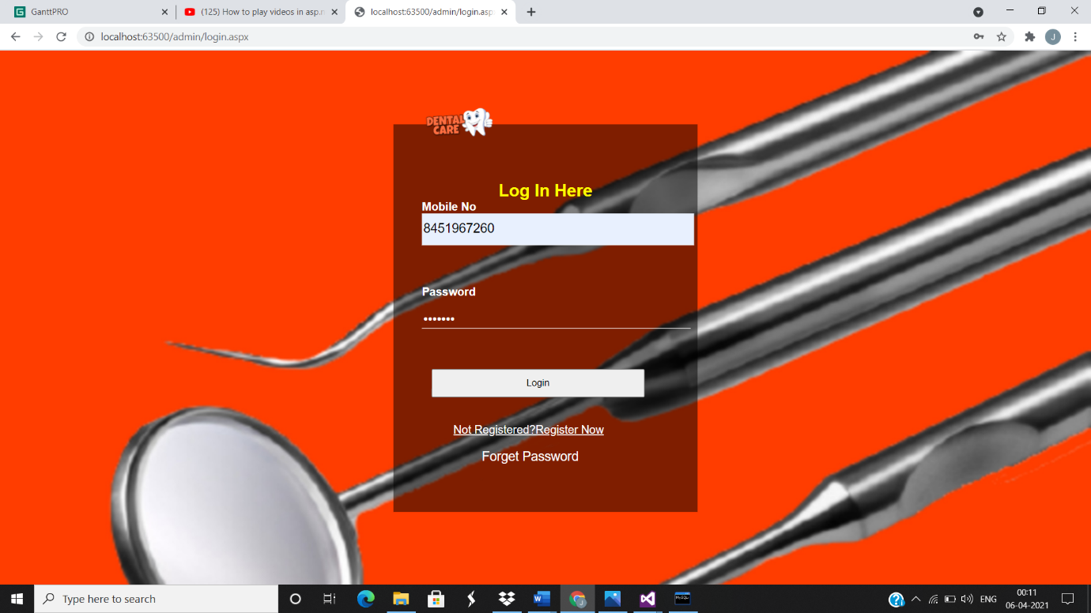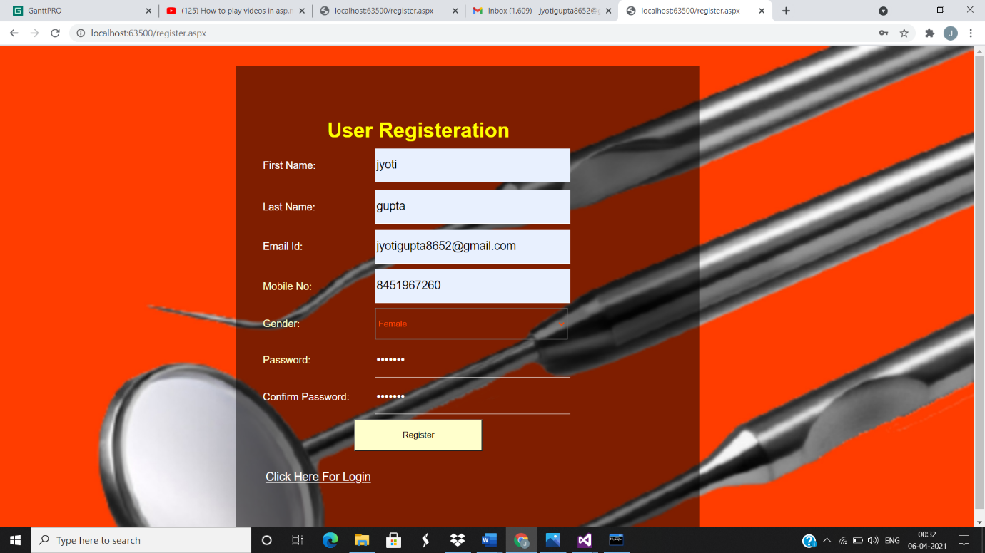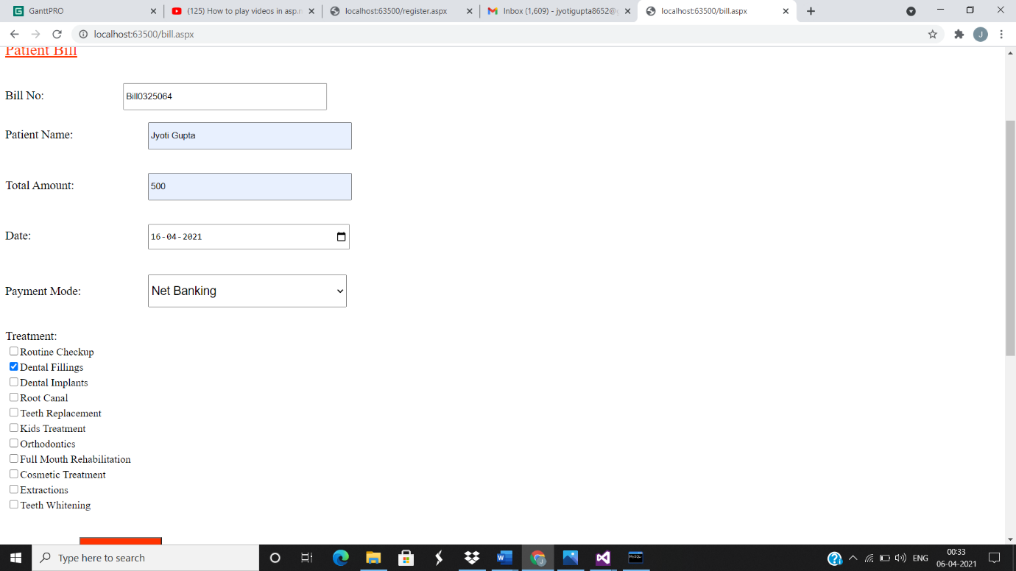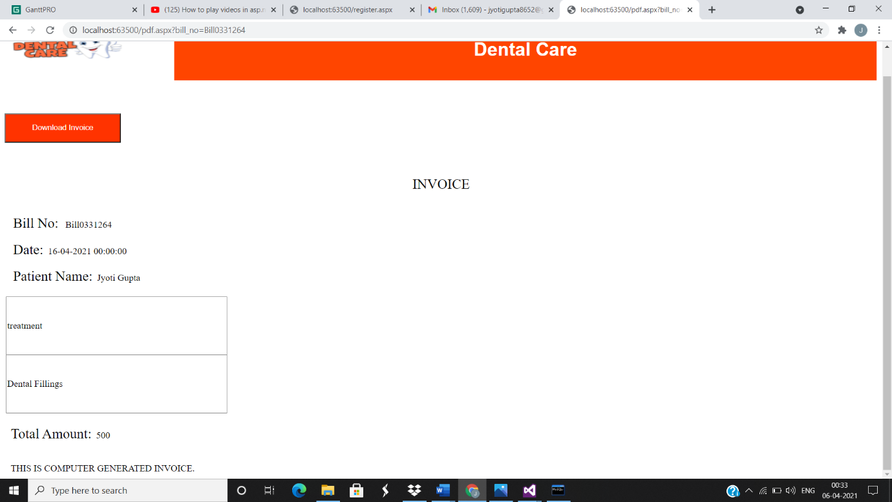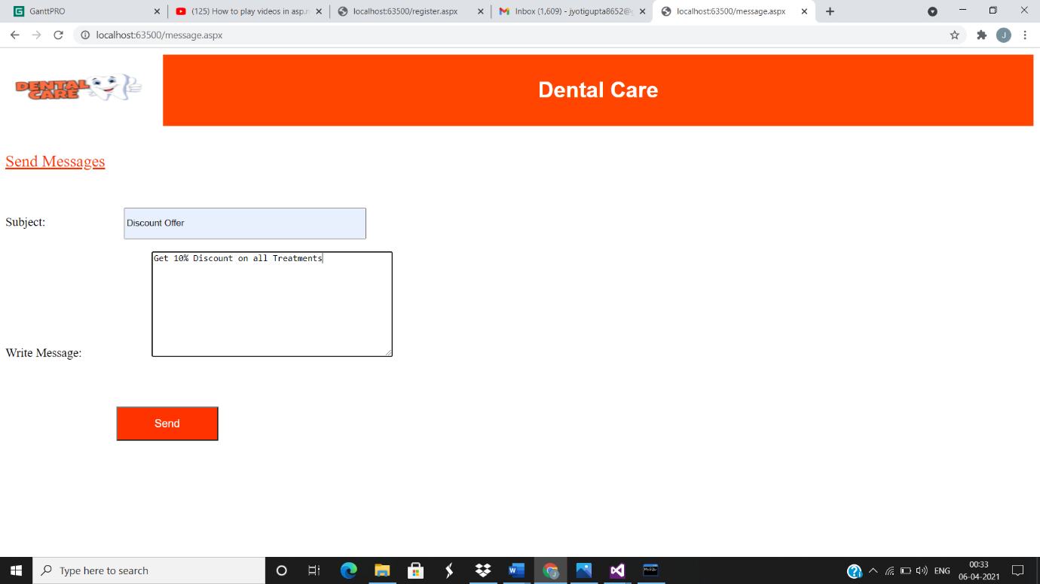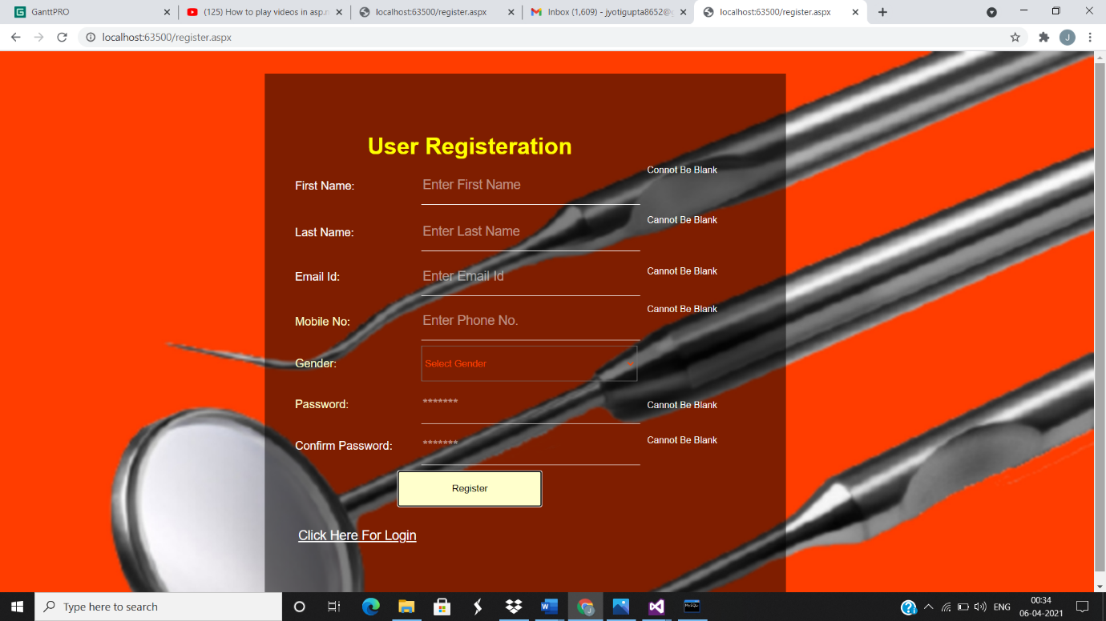

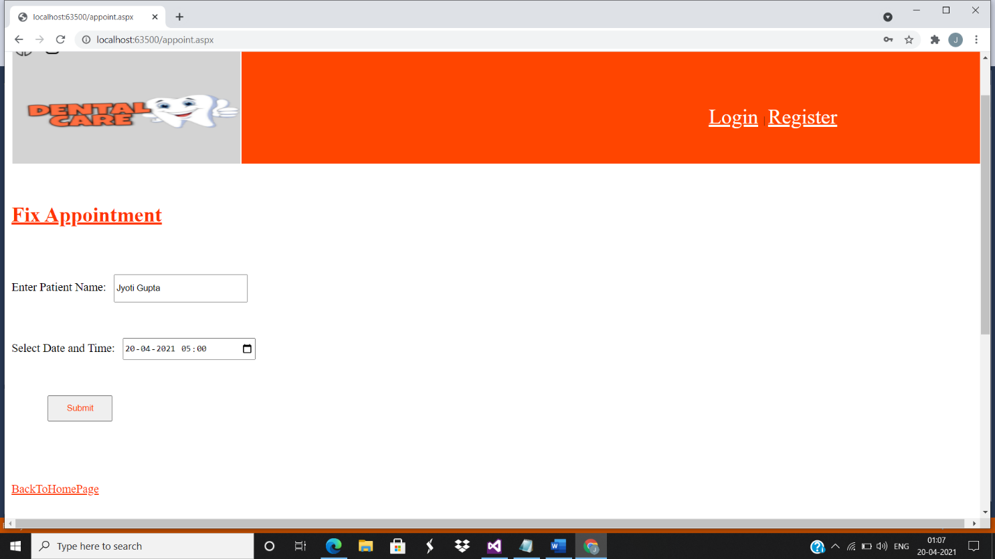

**6.3 Database Design/Tables:**

**Register Table**

|  |  |  |  |
| --- | --- | --- | --- |
| **Sr.no** | **Name of Column** | **Datatype** | **Constraint** |
| 1 | firstname | VARCHAR (20) | Not Null |
| 2 | lastname | VARCHAR (20) | Not Null |
| 3 | email | VARCHAR (40) | Not Null |
| 4 | phone | INT | Not Null |
| 5 | gender | VARCHAR (20) | Not Null |
| 6 | password | VARCHAR (20) | Not Null |
| 7 | category | VARCHAR (20) | Not Null |

**Appointment table**

|  |  |  |  |
| --- | --- | --- | --- |
| **Sr.no** | **Name of Column** | **Datatype** | **Constraint** |
| 1 | datetime | DATE | Not Null |
| 2 | name | VARCHAR (20) | Not Null |

**Bill table**

|  |  |  |  |
| --- | --- | --- | --- |
| **Sr.no** | **Name of Column** | **Datatype** | **Constraint** |
| 1 | bill_no | VARCHAR (20) | Not Null |
| 2 | name | VARCHAR (20) | Not Null |
| 3 | amnt | BIGINT | Not Null |
| 4 | date | DATE | Not Null |
| 5 | mode | VARCHAR (40) | Not Null |
| 6 | treatment | NVARCHAR (100) | Not Null |

**CHAPTER:7 CONCLUSION**

**7.1 Conclusion:**

This Web-Based Application is used to improve the management of the dental clinic and reduce the human efforts. The user can easily avail the services of the clinic by visiting this application from anywhere.

By logging in the user can easily fix an appointment for the consultation of the Doctor.

For logging in the user has to get themselves register by a very easy and minimal steps.

Because of the limited time frame, I am able to assure the entire functionalities of the system.

**7.2 Limitation:**

This application could be more attractive by using more colour themes.

This application will not work without the stable Internet Connection. For better connection you should have a good network connectivity.

This application can be used only when you have a hardware like Mobile Phones, Desktop, Laptop, etc.

**7.3 Future Scope:**

The system is flexible enough to add on more works in order to make it usable in large dental clinic, such as adding new modules.

The payment gateway for making payments can be added to the application.

Also has a plan to add the patient testimonial page in future.

**References:**

Stack Overflow:

<https://stackoverflow.com>

YouTube:

<https://youtu.be/OOLnq1WJsQU>

<https://youtu.be/NdXRC4U5cU4>

<https://youtu.be/vzfmBaoKxg4>

Codeproject:

<https://www.codeproject.com>